Parsinustan-ne Kahanis.
(Stories from Parsi homeland)

For the Diaspora ‘Y-Gen’ Zhamdins, who should have known, but were . . . . .
Too busy! (weren’t bothered?) To ask about their heritage.

Vignettes from Parsi History & Prospect – and the What IF? . . . . Factors!

Arrival . . . (Sunrise?) 2

Survival 3

Ethnicity 4

Education 5

Philosophy 6

Basic Prayers 7

Genesis of Family Names 8

Western Impact 9

Industry & Philanthropy 10
Parsi Prosperity 10

Parsi Luster on Indian Soil (Lord Wellingdon –Forward) 11

Few Notable – Noteworthy of the Clan

Dadabhay Navroji, Sir Jamsetjee Jejeebhoy 1st Baronet & Jamsetjee N. Tata. 13
Madam Bhikaiji Rustom Cama. 14
Bai Jerbai Nusherwanji Wadia. 15
Cornelia Sorabji 16
Sir Dhunjibhoy Bomanji. 17
Field Marshal. Sam Bahdur Manekshaw. 18
Sir Pherozeshah Mehta. 20
Sir Dinshaw Manockjee Petit. (First Baronet) 21
Homi Jehangir Bhabha. 22
Dastoor Meherji Rana. 23
Dr. Sir Ervad Jivanji Jamshedji Modi. 24
Kharshedji Rustamh (K.R.) Cama. 25
The Forgotten Gandhi. 26

Enduring Legacy: Parsis of the 20th Century (Review) 28

Bawajis’ Lament! . . . (Sunset?) 29
Blindly into the abyss. – ‏Bachi Karkaria – TOI. 30
Do Not Ostracize the Intermarried – Homi R Khusrokhan – Bombay Samachar. 31
Historical precedence – Mazgaon Navjotes of 1882. 32

End Notes 32

Referenced List (of Live links & available articles) 34

Compiled for the information my Grandchildren, the Diaspora ‘Y Gen’ & Others – from acknowledged sources.

- E. Kanga. Nov.2012
Vignettes from Parsi History & Prospect – and the What IF? … Factor!
With active links & articles available by request – for further readings.

There is no doubt, that Parsi history makes fascinating reading with stories of ‘Sugar in the Milk’ – ‘Saga’s of Survival & Settlement’ in a foreign land under difficult conditions; family names as memory of ‘Towns & Villages’ and the ubiquitous, exaggerated pseudo fables, as how ‘Parsi Pomp & Prosperity’ is based mostly on the ill-gotten gains of opium trade* in the 19th century. So, one gets to wondering . . . . What IF…?

Arrival: When our venerable ancestors fled Persia – in the 10th century AD – to protect, preserve & propagate their Mazdayasni Faith; setting sail from the ancient ports in the Persian Gulf, eastwards into the unknown Arabian Sea.
But … What If …? Destiny hadn’t favoured them by making land-fall at Diu, on the southern shore of the Kathiawar peninsular, allowing them to later sail to the west coast of the new land and into the friendly/fertile deltas of Narbada & Tapti Rivers of western India … But instead, their small ships tossed by storms and winds had forced them to make their initial landing in the ‘Gulf of Kutch’ – the seasonal salt marshes of the Thar Desert – in the land of the Rajput warrior clans, their chances of survival would have been slim if not dismal.
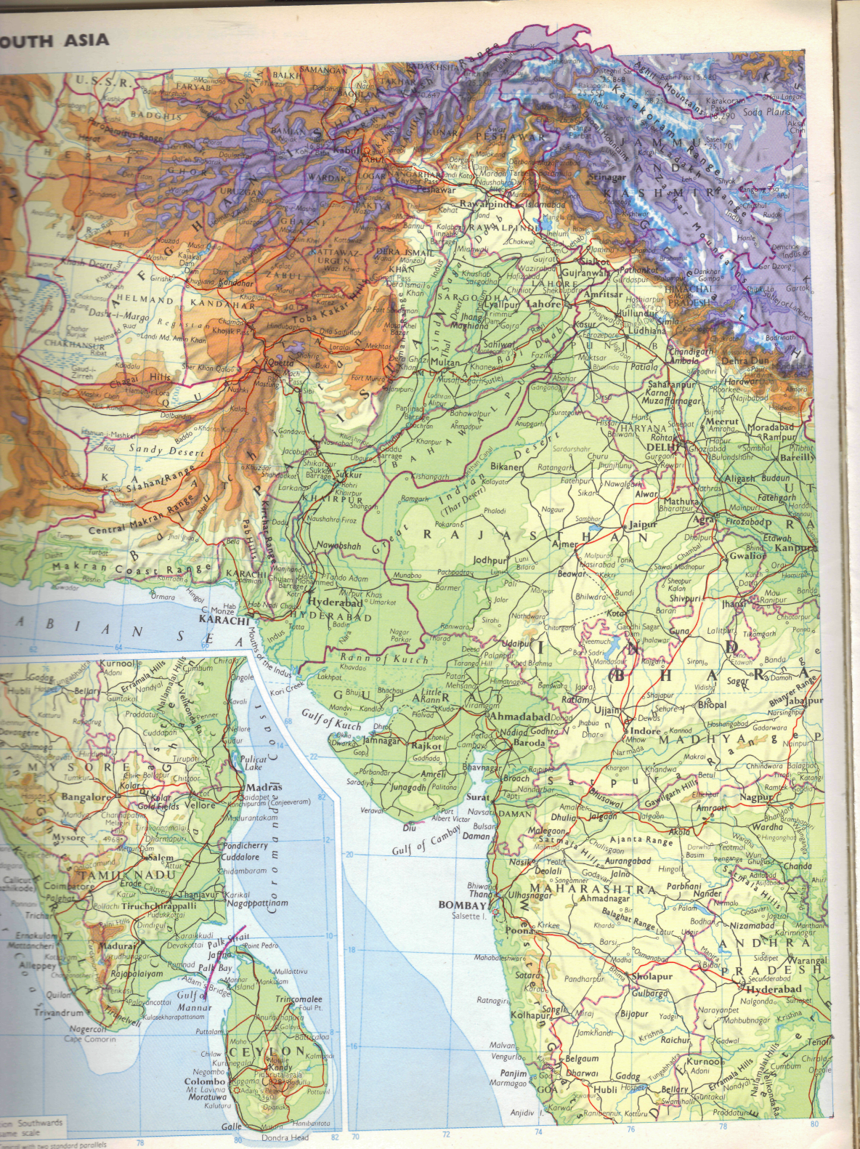
Alternately, what if, the winds had swept them past Diu, farther down the coast making landfall at the villages of the fisher-folks of Salsette Island, or even further, along the coast-line of the Western Gaths and land of the Maharatha warrior clans, the Parsa survival and fortunes would have been distinctly different, if not untenable.
In the Rann of Kutch, which is a white emptiness, a brilliant, frost-coloured land, burning the eyes with its whiteness. Not a bump, not a hump, not a shrub, not a bird, not even a breeze. Nothing! But, white in every direction. Horizon after horizon, on and on, for over two hundred miles east to west, & almost one hundred miles north to south; with very poor chances of survival at all, in such a barren and adverse moonscape.
While in the later case of a southern landfall, the narrow piece of land between the sea and the Western Gath foothills would have made survival equally difficult and dangerous, to subsist and thrive in the Shivaji clan’s homeland.
In either instant, early Parsi history would have recorded differently. ‘Blood in the Sand’ instead of ‘Sugar in the Milk’ for posterity.
Push the scenario of this desperate group of our forebears from Persia, even further south-wards on to the Karwar/Malabar coast; there they would have probably survived as fisher folks for a few centuries, but later, would have been forcefully converted into Christianity, by the Portuguese, who controlled vast sections of the western coastline of India.
In the 16th century – with Goa from 1530 onwards as Capital of Portuguese Indian colonies – forced conversion of the indigenous population into the Christian faith through the Grand Inquisition** by the Jesuit Francis Xavier, who had been granted all Orient by the Pope, as his territory for converting the heathens; was a constant occurrence on India’s W. coast.
Having considered the various W-IF scenarios of Parsa ‘Arrival History’ on the Indian sub-continent and acknowledging the fact that our community/faith survived & prospered for over a millennium in India only because, the people of the river deltas and hinterlands of the Gulf of Cambay opened up their hearts & homes to alien refuges, from across the Arabian Sea. During this span of a thousand plus years in India; that we, the Parsis have willingly embraced ‘the Customs, Cuisine and Culture’ of our gracious hosts of Gujarat, is a historical fact.
So, having acknowledged our gratitude to the people of Gujarat; It behoves us, the Parsa’s of today, not to indulge in juvenile ‘Gujju Jokes’ about our very own – ‘Kith & Kin’ of Gujarat. (E. Kanga)
* Article – ‘The Dragon Awakens’ -Giving true facts about the real players in this trade. – Available by request. (File Size 3.3MB)
** Article – ‘Auto de Fe’ Part II – Available by request. (File Size 1.3MB) → ‘Gujarat State’ 2011/12 Data – Available by request.

Survival: The existence of our Zoroastrian forebears and their faith in the new lands of western India, which depended greatly on the tolerance & understanding of the indigenous population. – What IF… It had been denied?
According to the ‘Qeṣṣa-ye Sanjān’ (The Story of Sanjān), the only existing account of the early years of Zoroastrian refugees in India – composed at least six centuries after their tentative date of arrival. Although the ‘Sanjan group’ are believed to have been the first permanent settlers, the precise date of their arrival is a matter of conjecture. All estimates are based on the Qeṣṣa, which is vague or contradictory with respect to some elapsed periods. A range of possible dates – 716 AD to 936 AD – have been proposed as the year of landing, and the disagreement has been the cause of much controversy between the 20th century scholars. Since dates are not specifically mentioned in Parsi texts prior to the 18th century, any date of arrival is perforce a matter of speculation.
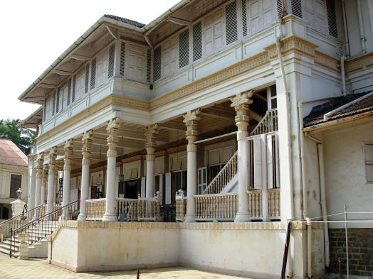
The importance of the Qeṣṣa lies in any case not so much in its reconstruction of events than in its depiction of the Parsis – in the way they have come to view themselves – and in their relationship to the dominant culture. As such, the text plays a crucial role in shaping Parsi identity. Even if one comes to the conclusion that the chronicle based on verbal transmission is not more than a legend, it still remains without doubt an extremely informative document of Parsee history.
The Qeṣṣa has little to say about the events that followed the establishment of Sanjan and restricts itself to a brief note on the establishment of the first Atash Bahram (Fire of Victory) at Sanjan and its subsequent move to Navsari. According to recorded history, the next several centuries were "full of struggle & hardships" before Zoroastrianism gained a foothold in India and secured for its adherents some means of livelihood in this new country of their adoption.
Two centuries after their landing, the Parsis began to settle in other parts of Gujarat, which led to Athornan (priest) family disputes in defining the limits of priestly jurisdiction. These problems were resolved by 1290 through the division of Gujarat into five panthaks (districts), each under the jurisdiction of one priestly family and their descen-dants. Continuing disputes on the jurisdiction over the ‘Iran Shah’ – Atash Bahram, led to the fire being moved to Udvada in 1742, where jurisdiction is shared in rotation between the five Zoroastrian. . ‘Iran Shah’ – located in Udvada Atash Bahram (Gujarat. India) panthak families.
“Then during Mogul Emperor Shahjahan's rule, a dark background of suffering and misery was seldom exposed to view. In the fourth and fifth years of his reign (1630-32), while the emperor usually was encamped at Burhanpur in Khandesh, intent on his aggressive schemes directed against the sultans of the Deccan, an appalling famine of the utmost possible severity desolated the Deccan and Gujarat. Between Surat and Burhanpur the ground was strewn so thickly with corpses that (one) could hardly find room to pitch a small tent. Historian, Abdul Hamid, makes no attempt to disguise the horror of the calamity, which he describes in vividness” (Excerpt: Oxford History of India – Vincent Smith)
The first Parsi settler came to Bombay from Gujarat in 1640, he was Dorabji Nanabhoy Patel. – Again in 1689-90, a severe plague epidemic broke out in Bombay and most of the European and other recent settlers succumbed to it.
These two epidemics in western India within six decades must have reduced the Parsi population to pittance. Hence it begs the question – how did the Parsi population of Gujarat and Bombay increase dramatically from these disasters? … If not by having out-of-wedlock & interfaith marriage children embraced into the Faith by our learned Dasturs of yore!?*
But, What IF…? Our legendary learned Dasturs had refused to consider this acceptable line of action** to help the Parsi community to grow again … Surely, we would have disappeared as a distinct society of India, a long time ago.
It’s high time we embrace our Faith in its true form, welcome children of interfaith marriages into the fold and stop considering ourselves as different; with some convoluted concept of ethnic purity & purpose. (E. Kanga)
* Article – ‘Conversion in Zoroastrianism’ All you wanted to know, but were afraid to ask! – Available by request. (File Size -13MB)
** “ “ – ‘Religion of Zarathushtra is for all Mankind’ by Cyrus Mehta. – Available by request. (File Size -50KB)
- “ “ – ‘CM - Narendra Modi addresses Parsis at Udvada’ – Available by request. (File Size -170KB)
Ethnicity: – Parsa’s Achilles heel?

A 2004 study in which Parsi mitochondrial DNA (matrilineal) was compared with that of the Iranians and Gujaratis determined that Parsis are genetically closer to the people of Gujarat, than Iranians. This does point to a lot of inter-mingling between the two communities having taken place over a long period of time.
Genealogical DNA tests to determine purity of lineage have brought mixed results. One study supports the Parsi contention (Nanavutty 1970, p.13) that they have maintained their Persian roots by avoiding intermarriage with local populations. In that 2002 study of the Y-chromosome* (patrilineal) DNA of the Parsis of Pakistan, it was determined that Parsis are genetically closer to Iranians than to their (Pakistani) neighbours (Qamar et al. 2002, p. 1119)
However, a 2004 study in which Parsi mitochondrial DNA (matrilineal) was compared with that of the Iranians and Gujaratis determined that Parsis are genetically closer to Gujaratis than to Iranians. Taking the 2002 study into account, the authors of the 2004 study suggested . . . . "A male-mediated migration of the ancestors of the present-day Parsi population, where they admixed with local females [...] leading ultimately to the loss of mtDNA of Iranian origin" (Quintana-Murci et al. 2004, p. 840) <>

Re: The article – ‘Zoroastrians Search for their Roots’** by Zubair Ahmed [BBC News, Mumbai. 19 July 2005] … The following was my ‘Reader’s Comments’ sent to the news media in 2005.
=======
Sir … … With reference to the tragicomic article ‘Zoroastrians Search for their Roots’ by Zubair Ahmed [BBC News,
Mumbai; 19 July 2005] – the following excerpt from the ‘The Vanishing Breed’ by Jehangir S. Pocha. [Oct 2004] makes this ‘urge to connect with their Persian past’- by the Parsis’ of India – however tenuous – comically understandable.
“… Many modern Parsis are increasingly pushing for change, but conservatives such as Mistree say their ‘over-westernisation & over-secularisation is killing our Parsipanu’ [i.e. Parsi way of life]. This finds resonance with many Parsis who believe the best way to secure their community's future is to hold fast to the past. For example, more and more Parsis, myself included, have begun visiting Iran in an attempt to reinvigorate their affinities with Zoroastrian Persia's Grand Past. This has given rise to what I call the ‘Über-Parsi’. Über-Parsis cruise public libraries and surf the Web to excavate obscure facts and reacquaint the world with the ancient Achaemenian, Parthian and Sassanian -Persian dynasties- which were the cultural and military superpowers of their times, eventually outlasting their rivals, the Greeks and the Romans. Über-Parsis are easily made, for Parsis are not defined by how small they are in number, but by how great they are in mind. But curating history can only go so far in energising a community. In many homes the attempt to cull present meaning from Persian history descends into farce. These are homes where glossy picture-books on ancient Persia lie strategically on coffee tables, a silver bookmark from Tiffany’s thrust carelessly between pages never opened. If at all the books are read, it is to satisfy the thirst for that latest trend of Parsi parents - the quest for a ‘different’ name with which to name sons and daughters. Names like Artaxerxes, Sohrushmani, Cambyses; bludgeon friends with their ancient authenticity & reassure parents that their children will always be regarded as ‘special’ & they as refined Parsis.” (end of quote)
Now in my opinion, the truly tragic part of the BBC’s reported article and above excerpt, is that after more than one thousand two hundred years of residing in a relatively safe and stable environment in India, we still have some in the community that consider themselves as being of pure Persian/Iranian origin. How tragic indeed, when I hear some Parsis wistfully state that one group of Zoroastrians fled to Europe instead of India, and claim that the picture of a white robed, bearded old man, holding a small fire urn in his hand, is indeed proof of this; a European representation of a ‘German Zarathushtra.’?!? . . . . In reality, it’s a post exile picture of the Jewish Prophet Isaiah.
It is high time we Parsis give our venerable ancestors credit for their wise choice of destination for the safe future of the community and religion; that could survive only in a country which practiced the principle of ‘freedom from religious persecution’ for millennia . . . . . . . The only country, INDIA!
As soon as we Parsis accept the fact that the centuries of Parsi Prominence and Prosperity (c.1760-1960) on the Indian subcontinent has passed; and that as proud Indian Nationals, we should be more in tune with what our forefathers achieved in India – instead of, for ever talking about the ancient Persian Achaemenian, Parthian and Sassanian dynasties, as our source of pride – we will soon grow out of this malaise.
Now about the claims – made by those interviewed in afore referenced BBC article – ‘of genetic memory’ as the reason for this ‘urge-to-search & connect’ by the Parsis for their roots. . . . Their genetic roots theory seems to go back only between circa 600BCE to 600CE. . . . . . . Now my genetic memory goes back to our Prophet’s time of c.6000BCE. So in-fact, my Yatra is going to take me to the present day countries of Tajikistan, Uzbekistan and Turkmenistan; area known as ‘Arya-na Vaeja’ in the Vendidad, wherein our Prophet ‘Walked-the-Talk’ and converted King Vishtasp into the Faith. . . . . . If and when I do return, with Head-&-Hide intact! I shall regale one-and-all with stories of this journey for the search of my antiquated roots.
But as of now, after ‘twelve centuries’ of Parsi ancestral history at hand; I proudly proclaim that my Zoroastrian genetic roots, ancestral home and country of origin, is indeed – INDIA! *** (E. Kanga. Aug ’05)
*‘Y-Chromosome – Indo-European language & Blood Types’ – Available by request. (File Size - 5MB)
**‘Zoroastrians Search for their Roots’ by Zubair Ahmed – Available by request. (File Size -80KB)
***‘FYI – A Celebration of Human Genetic Diversity over Millennium’ – Available by request. (File Size -115KB)
→ Article – ‘Religious Impulse & Evolution.’ by Gopi Krishna – Available by request. (File Size – 30 KB)
Education: A few weeks back, I had just finished reading ‘Three Cups of Tea’ by the American mountaineer Greg Mortenson, documenting his astonishing story of a real-life Indiana Jones adventure and his remarkable humanitarian campaign in the mountain villages of Pakistan – in the Taliban’s backyard. It started when he drifted into an impoverished village in the Karakorum Mountains after a failed attempt to climb K2. Moved by the village head and the inhabitant’s kindness, he promised to return and build a girl’s school in that remote village in Baltistan region of Pakistan, as per their wishes & request. It takes Mortenson a decade to collect enough funds to build the girls’ school for Korphe village. (A must read account)
Then last week, an attempt on the life of a 14year Pakistani girl, Malala Yousafzai* by the Taliban, because she is an outspoken crusader for girl’s education – one gets to wondering . . . . What IF?

What IF – in the past two centuries; our enlightened Parsi Sethias & Akbar’s of the Faith were, as-myopic-as, ones in our midst today; . . . . would we be having similar incidents in the Parsi community?** (E.Kanga)

Sooni Taraporevala’s comments at 9th World Zoroastrian Congress, gives one an inkling & reasons to worry!?
”It is a matter of great sadness to me that we, the Parsis of India, who were once at the forefront of reforms the first Indian community to embrace change, seem to be sliding backwards in many ways–into the DARK AGES”

[Following – an excerpt from: ‘The Good Parsi’ by Tayna M. Luhrmann. (pg. 133-4) – ISBN 0-674-35675-6]
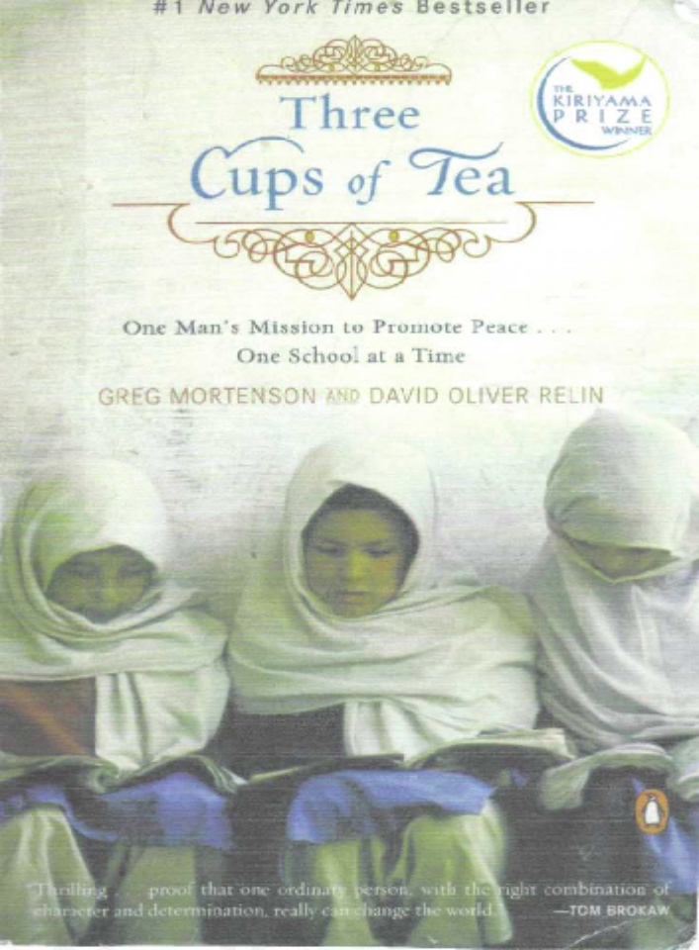
… Parsis began to treat their women like western progressive women, in the nineteenth century.
A turn-of-the-century Parsi woman proudly explained that Parsi women “live a natural life, enjoy their games, can admit of a childhood, as-well-as, a womanhood and are fast becoming splendid companions for their husbands; it is no longer a rule but an oddity when a Parsee husband spends his evenings away from his home. (Cavalier 1899). Parsis were among the first communities in India to educate their women, doing so in English from 1860. (Hinnells n.d.1.)
By 1870, over a thousand Parsi women had received secondary education (Kulke 1974:104).
One article pointed out how the community realised by 1849 that “for social and intellectual advancement of their respective communities, no means could be more hopeful & fruitful than the education of girls.” [43] Private homes were used for some years until, in 1858; the Parsi Girls School Association was formally inaugurated.
There are pictures of students of the Tata Girls School at Navsari, taking first-aid classes, and accompanying essays on a convalescent home for women & children and “Parsi Ladies as Educationists.”
Most dramatically, Parsis spoke English. In the mid-nineteenth century, Parsis built more schools & attended school more regularly than other communities, proportional to their numbers (Hinnells n.d:1). By 1881 – 74% of the community was literate. (Hinnells 1978:52).
By 1901, more than a quarter of the community spoke English, as compared to less than one percent of the Jains and half a percent of the Hindus. (Axelrod 1974:31); 63% of Parsi women were literate and nearly all the men. (Hinnells n.d.:2)
In 1899 an English Newsletter remarks, “The Parsis are most loyal to England, and nearly all the younger generation speak English well.” [44] In 1906, a journal article comments: “the love of English literature has spread among the women-kind of Parsis more widely and more rapidly than among any other nationality in India. Of this, there can never be two opinions.” [45]
‘Men and Women of India’ – self-advertised as the only society magazine in India – devoted a special issue to the Parsis in 1906. Bombay Parsis, – the magazine suggests – are delightfully English. … After I (author Luhrmann) had written the first draft of this book, I met a man who had been stationed in the British military in Bombay during the war. I asked him about the Parsis. “Oh! He said, they were the very nicest Indians, and they were so well educated.”
* http://thelede.blogs.nytimes.com/2012/10/09/my-small-video-star-fights-for-her-life/?smid=fb-share ** ‘Talibanisation of Zoroastrianism’ by P. Kakodkar. – Available by request. (File Size - 40KB)
Philosophy:

Philosophy of the ‘Foremost Prophet’

Live in …  … the Light,
Of harmony with man & nature;
Opposing the lie – the pompous stature.
With Good Thoughts* – Good Friends – Good Health;
Cleansed in body, mind and spirit . . .
Go laughing through life with Asha.

This in essence, is the philosophy of ‘The Good Life’ of prophet Zarathushtra.
~---------------------------------------------------------------------------------------------------------------------~
*The practice of ‘Good Thought’ precludes the necessity to add:
Good words & Good deeds.
Every word spoken & action performed – is always preceded by:
A thought – good or evil.

‘Asha’ = ‘Path of the Righteous’

* * * * * * *

Watch your Thoughts; . . . They become your words.
Watch your Words; . . . . . They become your deeds.
Watch your Deeds; . . . . . They become your habits.
Watch your Habits; . . . . . They become your character.
Watch your Character; . . It becomes your Destiny.

===============

KARMA – is the game of LIFE!
Our Thoughts, Words & Deeds – return to us;
With astounding accuracy.

Light a . . .  . . . Divo
In Mazda’s name; who creates – all Consciousness.
In Zarthost’s name; who revealed – the path of Righteousness.
In the Sprit’s name; that is – the Essence of Life.
Be Still! . . . Let the Divine presence – Engulf you in the Light.

"To fight Darkness – Do not draw your sword;
Instead – Light a candle"
* * * * * * *
“. . . . . Kshathrem-ca Ahurai a | yim drigubyo dadat vastarem.” Yasna 27.13
(and) the Strength of Ahura is given unto him | who unto his poorer brother giveth help. I.J.S.Taraporewala.
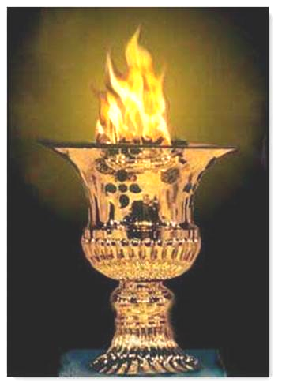
Parsis must bear in mind that the ‘The Flame’ is representation of Mazda’s –‘All encompassing Light of Creation’– and its presence during prayer, reminding them that the prophet’s first proclamation to his disciples was to follow the path of ‘Spenta Manyus’ (Path of living in the Light of Truth) and oppose ‘Angra Manyus’. (Path of Darkness of the Lie). Forces influencing mankind’s choice of ‘Good or Evil’ – life’s path. (E. Kanga)
→ Article – ‘Living in the Light’ – Available by request. (File size – 240KB)
An E.Kanga. © collection.
Basic Prayers:
Four prayers which all Zoroastrians recite daily – with meaning.

ASHEM VOHU

ASHEM VOHU VAHISHTAM ASTI
USHTA ASTI USHTA AHMAI
HYAT ASHAI VAHISHTAI ASHEM

‘Righteousness is the best good;
It is enlightenment – & enlightenment is to one
Who is righteous for the sake of best righteousness.’

Explanation: One follows the path of Asha, not with the thought that one will go to Heaven or otherwise go to hell but simply because this is the only way mankind can have happy and progressive society. When this has dawned on a person, he/she has obtained enlightenment.
====
AHUNAVAR

YATHA AHU VAIRYO ATHA RATUSH ASHATCHIT HACHA
VANHAUSH DAZDA MANANHO SHYAOTHANANAM ANHAUSH MAZDAI
KHSHATHRAMCHA AHURAI A YIM DRIGUBYO DADAT VASTARAM

‘Just as the ruler is supreme, so is the religious teacher through his righteousness;
By the deeds of good thought – done by a person in helping the poor,
Makes for the kingdom of Ahura Mazda.’

Explanation: There are two messages in this—
1. The religious teacher who practices morality and teaches us morality and thus looks after our spiritual side, is treated as high as the ruler or the Government who looks after our safety and physical side and well-being,
2. Helping the poor and needy is a path to Ahura Mazda.
====
YENGHE HATAM

YENGHE HATAM AAT YESNE PAITI VANGHO
MAZDAO AHURO VAETHA ASHAT HACHA YAONGHAMCHA
TASCHA TAOSCHA YAZAMAIDE

‘All human beings whom Mazda Ahura recognizes as pure, in every act of devotion,
Ever associated with righteousness, all such women and men we adore and honor.’

Explanation: Zarathushtra was envisaging a society where only such men and women who are righteous in their acts are respected and honored --irrespective of their work /occupation. Money-bags or muscle men are not respected—(they will be respected only for their acts of righteousness). Also one can see that this is perhaps the oldest scripture in the world where men and women are put on the same platform—equality of sexes is one of the basic messages of Zarathushtra.
====
AIRYAMA ISHYA

A AIRYAMA ISHYO RAFEDHRAI JANTU
NARABYASCHA NAIRIBYASCHA ZARATHUSHTRAHE
VANGHEUSH RAFEDHRAI MANANGHO YA DAENA VAIRIM HANAT MIZHDEM
ASHAHYA YASA ASHIM YAM ISHYAM AHURO MASATA MAZDAO.

‘May the tribe zealously approach for the support of Zarathushtrian men and women!
With the support of Vohu Mana,(good mind) and whose spiritual insights merit the desired prize.
I / we zealously entreat that truthful reward which Ahura Mazda has ordained.’
====
Many Dasturs claim that these 4 basic prayers are ‘Holy manthras’* – Such statements tend to mislead the hamdins into thinking that these prayers are magic spells. It is wrong for the mobeds to so mislead the laity. These prayers are not some ‘magical spells or incantations’ to be repeated ‘ad nauseam’ for luck, protection, fame & good fortune etc ... But they are very clear and precise edicts / instructions by the Prophet to His followers; as you can discern from the English translations of the same four prayers.
I have underlined those precise edicts/instructions in the above translations, to make my point. (E. Kanga)
* Manthra: A repetitive chant practiced by other faiths; without thinking & closely associated with magic spell or mystic transformation.
Genesis of Parsi Family Names

Many Parsi surnames are based on the original area or town the family patriarch hailed from –e.g. Bharucha (of Bharuch); Anklesaria (of Ankleshwar); Surti (of Surat); Khambata or Cambata (of Cambay); Damania (of Daman); Sanjana (of Sanjan); Balsara (of Balsar); Nargolwalla (of Nargol); Adenvala (from Aden – Saudi Arabian peninsular). Tata (of Tatta, in Sind. Not shown on the map); Kanga (of Kanga-clan mollha in Navasari; & not from the ancient ‘Kangavar’ in western Iran). Kamdin (Kama+Din i.e. Kama of Din i.e., Faith).
Some have surnames based on the patriarch’s profession; e.g. Dastur, Panthakee, Captain, Driver, Mistry, Mehta, Patel, Merchant, Contractor, Cooper, Doctor, Gandhi & the classic, Sodawaterbottleopenerwalla.
Others as, just the patriarch’s first name e.g. Mirza, Mancherjee, Merwanjee, Tehmuljee, Pallonji, Jama(s)ji, Hom(i)ji, Dorabjee & some others as (son + father’s) conjoined as family names e.g. Dada(son-of)Chanji as Dadachanji, Dadyburjor – and of course, the most famous – MeherjiRana, etc.
Finally, the surname Irani refers to Zoroastrians from Iran who came to India in 18th & 19th century.
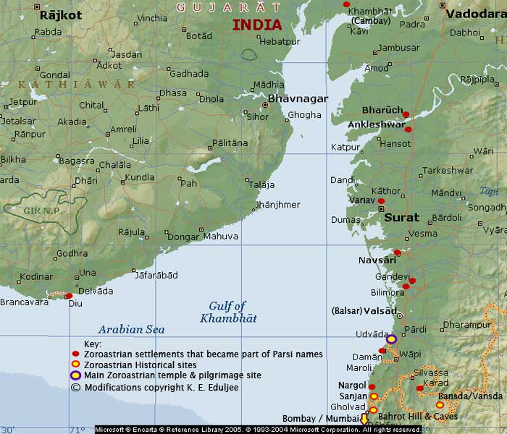
Gujarat West Coast – showing Zoroastrian settlement sites & Udvada (Iran Shah location)
→ See the ‘Sabarmati River Front Project’ – Video Link. – http://www.youtube.com/watch?v=4rNQOq1wSfs

‘Next year in Udvada!’ – A Parsi Prayer? E. Kanga.
Western Cultural Impact:

‘ANGLICISATION OF THE PARSIS’* by Dr. Polly Noshir Chenoy – (Following is an excerpt.)
[But], the Anglicisation of the Parsis has a longer and deeper history and cannot be confined merely to the problem of our children speaking no other language except English.
When they landed in India, the Parsis realized that their hope of survival and of living in peace lay in being strictly loyal to their rulers and taking no part in the tension and conflicts surrounding the courts of Princes or in the regions they inhabited. The adaptability of Parsis was clearly manifest when they adopted Gujarati as their mother tongue and also agreed to the condition that their women folk would abandon their Persian mode of dress and don saris instead.
Hence the Parsis, through good sense, a sense of adaptability and their display of loyalty managed not only to survive, but at the same time, were able to strictly preserve their identity and their religion. This same quality of adaptability among the Parsis is observed by Mmle Menant in her book ‘Les Parsis’ when she remarks: **
"Possessed of a wonderful assimilative power, they made light of Hindu customs, as, long before, they had sacrificed their Iranian habit at the pleasure of the Ranan of Sanjan." But like all other writers she observes: "Mazdayasnans and Zoroastrians they remained. Their profession of faith has not changed."
Ever since the sixteenth century, Surat has been attracting the Parsis at an increasing rate being the most important seaport on the west coast of India, and at the same time, a trade center for both the Moghul and European trading companies. By the ‘seventeenth’ and 'eighteen' centuries, Surat became the largest Parsi settlement. The Europeans preferred the Parsis to act as their "brokers" because they had knowledge of the languages and of the land they were living in. Not being hampered by taboos of caste and creed gave them enough flexibility to have commerce with the foreigners.
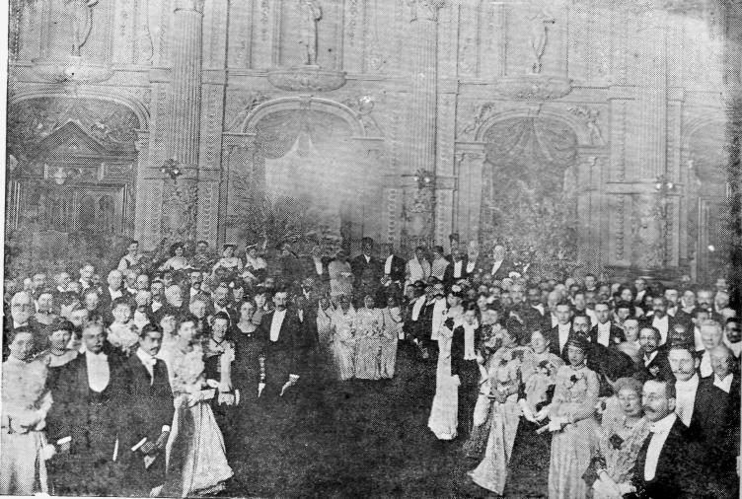
1902 London: Reception held in honour of Sir Jamsetjee Jejeebhoy. (Bart. 4th)
On the dais with Sir Jamsetjee Jejeebhoy were: Dadabhai Naoroji; Lady Gulbai Jamsetjee Jejeebhoy;
Field Marshal Lord Roberts of Khandahar; Miss Virbaiji Jejeebhoy (Mrs. J. D. Daver); Rustomjee Jejeebhoy. (Bart. 5th)

According to D.F. Karaka, the author of the ‘History of the Parsis’, "The Portuguese, French, Dutch and English factories all employed Parsees as their chief brokers".[1] And as Eckehard Kulke says: "Close contact with the Europeans gave the Parsees the 'know how' of European trade and business organization and so laid the foundation for their subsequent economic and social rise under English rule".[2]
J.R.E. Jeejeebhoy in his Introduction to ‘Parsee Lustre on Indian Soil’ mentions that "as years rolled on the Parsees made themselves indispensable to the English who ever since their arrival in India looked upon them for support and co-operation".[3] This created a bond between the English or European races and the Parsis as communication between them was free and easy.
The Parsis flowered and prospered under British rule. In 1907, Khusrau Edalji Ghamat stated: "The prosperity of the Parsees dated from the advent of the British rule in India" [4] He was justified in making this statement, for the British rule gave India peace, legal security, modern education and at least to the Parsis, economic prosperity. Therefore, the apprehension of the Parsis that as a minority community they would become unimportant once India gained independence, is manifest in a speech given by Sir Jamsetjee Jeejeebhoy at a meeting on the occasion of the coronation celebration in 1902:
“... The best course, therefore, for the Parsi community as well as all the other communities, who are in a hopeless minority, is that they must stand up for the British raj which distributes favours amongst all with strict impartiality".[5]
The Parsis, therefore, identified themselves with the colonial power and this attitude was especially evident during the Mutiny of 1857 when they helped the British in fighting insurgency, in gaining lost territory, and gathering information of enemy movements. And the British knew how to channel the energies and resources of the Parsis by recruiting them for white collar administrative tasks in the middle of the nineteenth century, such as assistant collectors, translators at courts, sub-assistant surgeons and postmasters. As Kulke states: "everywhere, where new professions were to be made accessible to Indians, Parsis appeared immediately in above average numbers"
* ‘ANGLICISATION OF THE PARSIS’ by Dr. Polly Noshir Chenoy – Full article by request. (File Size – 180KB) ** Delphine Menant’s, ‘Les Parsis’ vol.II, Translated M.M. Murzban (p.9)
Two examples from Parsi History on . . . .

Industry & Philanthropy:
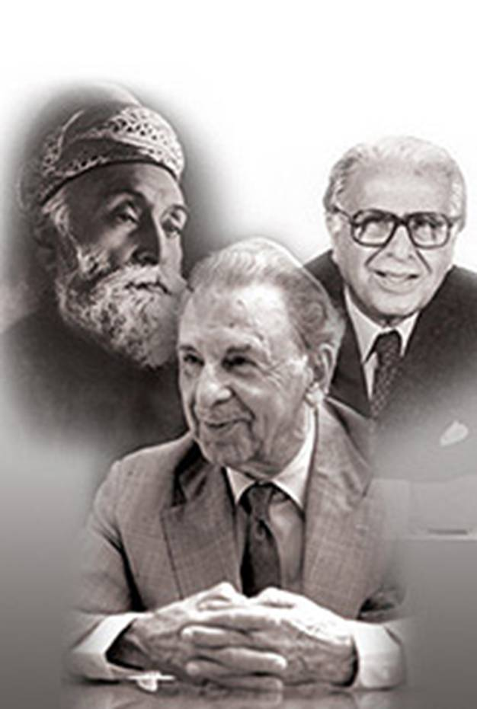
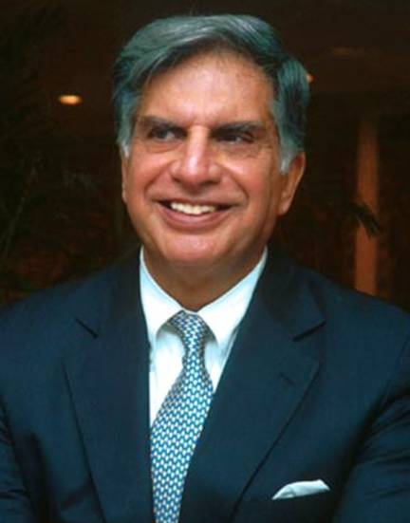
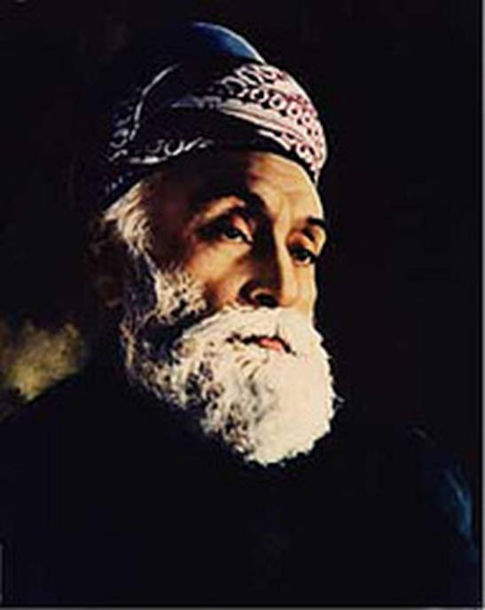

JAMSETJI N. TATA. JEHANGIR R.D.TATA. RATAN N. TATA.
→ Article – ‘+The Tata Group History 1868- 2012’ – Available by request. (File Size – 1.34 MB)

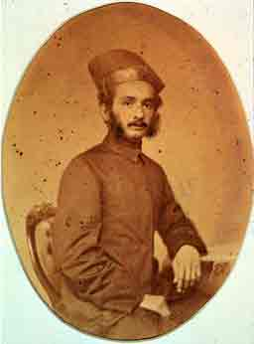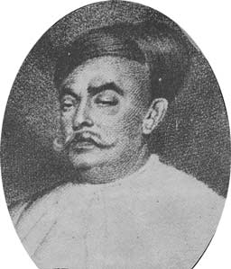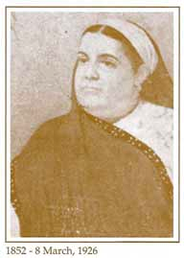
Rustomji Hirjeebhoy Wadia, c.1859 Jamsetji Bomanji Wadia, Master Builder Bai Jerbai Nusherwanji Wadia
→ Article – ‘The Wadias of India: Then & Now’ by Khorshed Jungalwala. – Available by request. (File Size – 170KB)

Ahunavar’s third precept should be our guiding – * – i.e., Third Principle of Life . . . To Serve!

“. . . . . Kshathrem-cha Ahurai a | yim drigubyo dadat vastarem.” – Yasna 27.13
(and) the Strength of Ahura is given unto him | who unto his poorer brother giveth help. – Dr.I.J.S.Taraporewala

Legendry Parsi Prosperity:

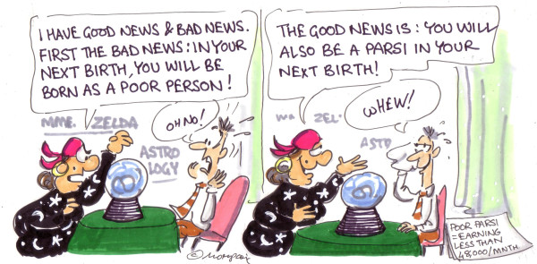
→ http://www.cnngo.com/mumbai/life/what-would-mumbai-be-without-its-parsis-032539 ←
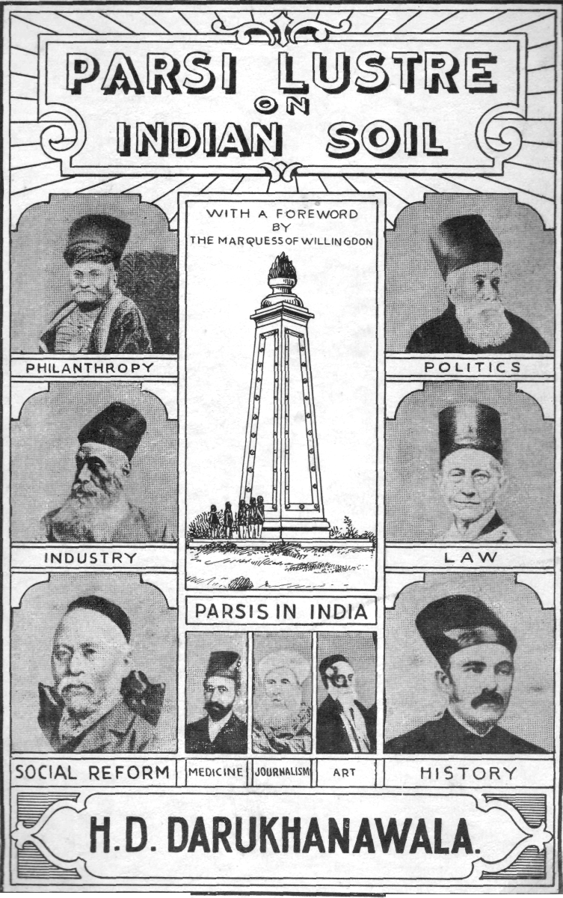
2-Volume set – Parsi impact in their various fields of endeavour.
Over 650 individual named entries are recorded in each of the 2-Volume set.

FOREWORD BY – LORD WILLINGDON. P.C., G.C.S.I., G.C.M.G., G.C.I.E. G.B.E.
Nothing could give me greater pleasure than to write a short 'Foreword' to a book which tells us, through an account of many of its individual leaders, the romance of the history of the Parsi community from the time that they left their original homeland in Persia and established their headquarters in India in the city of Bombay.
Mr. J. R. B. Jeejeebhoy's admirable and most interesting introduction gives us an historical account of their many adventures and activities from the early days of their sojourn in India up to the present time, and mentions many names of old friends of mine who have been great leaders in the political, industrial, commercial and social life of the country, men and women who have been pioneers in the general development of India whether from the business and social side of lives of the people, or in the regions of sport and play.
My close association with many members of the Parsi community began in the year 1913, and I am glad to have this opportunity of gratefully acknowledging the constant help and encouragement I received from them during the six years of my life as Governor of Bombay, and their unfailing friendship and kindness to me during the further ten years that I lived there as Governor of Madras, and as Viceroy of India.
The romance of the Parsi community in India will always remain in my mind as one of the most interesting recollections of my life there. Arriving as they did as strangers long years ago, they have completely identified themselves with the land of their adoption, and though their community is a small one, infinitesimal compared with the great Hindu and Mahomedan communities that live alongside them, they have produced outstanding leaders who have exercised great influence over the public life of the country. My confident hope is that they will continue to exercise that influence in the future, and help their fellow citizens steadily and surely to move forward to their goal of Dominion Status, complete partnership in the British Commonwealth of Nations with the other Dominions under the Crown.

Walmer Castle, Deal, Kent,
May 1938.
FEW NOTABLE – NOTEWORTHY’S of the CLAN

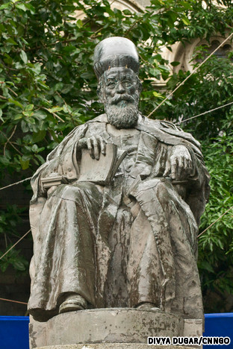
Dadabhay Navroji (4 Sept.1825 – 30 June 1917) known as the Grand Old Man of India, was a Parsi intellectual, educator, cotton trader, and an early Indian political and social leader. His book Poverty and Un-British Rule in India brought attention to the draining of India's wealth into Britain. He was a Member of Parliament (MP) in the United Kingdom House of Commons between 1892 and 1895, and the first Asian to be a British MP. He is credited with the founding of the Indian National Congress, along with A.O. Hume & Dinshaw Edulji Wacha.
At the early age of 25, he was appointed leading Professor at the Elphinstone Institution in 1850, becoming the first Indian to hold such an academic position. By 1855 he was Professor of Mathematics and Natural philosophy in Bombay. Later, he became professor of Gujarati at University College London.
In 1867 Naoroji helped establish the East India Association, one of the predecessor organizations of the Indian National Congress with the aim of putting across the Indian point of view before the British public. In 1874, he became Prime Minister of Baroda and was a member of the Legislative Council of Bombay (1885–88).
He died in Bombay on 30 June 1917, at the age of 91. Today the Dadabhai Naoroji Road, a heritage road of Mumbai, is named after him.
→ http://en.wikipedia.org/wiki/Dadabhai_Naoroji .

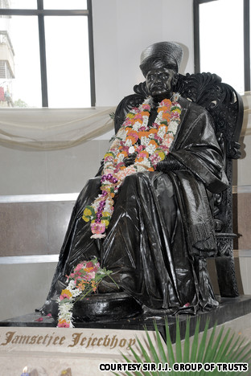
Jamsetjee Jejeebhoy (1783 – 1859) Born in Bombay to poor parents, who died shortly afterwards, leaving him an orphan. At the age of sixteen, having had little formal education, he made his first visit to Calcutta and then began a series of voyage to China to trade. In time Jejeebhoy established his reputation as an enterprising merchant. He settled in Mumbai, where he directed his commercial operations. By 1836, Jejeebhoy's firm was large enough and he had amassed what at that period of Indian mercantile history was regarded as fabulous wealth.
Some of Jejeebhoy's notable charitable works:
Lady Avabai Jamsetjee Jeejeebhoy spent Rs.1,55,800 to finance the construction of Mahim Causeway between Salsette Island and the mainland. The work began on Mahim causeway in 1841 & believed to have been completed four years later.
Jamsetjee Jejeebhoy donated to at least 126 notable public charities, including the Sir J.J.Hospital, the Sir J.J.School of Art, the Sir J.J.College of Architecture, the Sir J.J. Institute of Applied Art and the Seth R.J.J. High School.
He also endowed charities dedicated to help his fellow Parsis community and created the Sir Jamsetjee Jeejebhoy Parsi Benevolent Fund.
Jejeebhoy's services were first recognized by the British Empire in 1842 by the bestowal of a knighthood and in 1858 by the award of a baronetcy.
→ http://en.wikipedia.org/wiki/Sir_Jamsetjee_Jejeebhoy,_1st_Baronet .

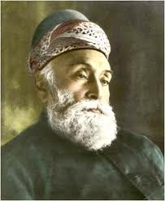
Jamsetji Nusserwanji Tata (3 March 1839 – 19 May 1904)
Indian industrialist, who founded the Tata Group, India's biggest conglomerate company. He was born to a Parsi family in Navsari, Gujarat, India.
Jamsetji joined his father in Bombay at the age of 14 and enrolled at the Elphinstone College. He graduated from college in 1858 and joined his father's trading firm. It was a turbulent time to be in business as the Indian Rebellion of 1857 had just been suppressed by the British government.
At age 29, he founded a trading company in 1868. He bought a bankrupt oil mill in Chinchpokli in 1869 and converted it to a cotton mill, which he renamed Alexandra Mill. He sold the mill two years later for a profit. Cotton mill in Nagpur in 1874 & called it Empress Mill when Queen Victoria was proclaimed Empress of India in 1877. He is regarded as the "Father of Indian Industry".
He devoted his life to four goals: setting up an iron and steel company, a world-class learning institution, a unique hotel and a hydro-electric plant. Only the hotel became a reality during his lifetime. His successors' work led to the three remaining ideas being achieved. The Company started by Jamsetji Tata came to be known as the Tata Group and is today among the largest private sector firms in the world. He died in Nauheim, Germany on May 19, 1904. → http://en.wikipedia.org/wiki/Jamsetji_Tata
& The TATA GROUP in 2012 →Ratan Tata’s second act. pdf – Download (4.7MB).

Madam Bhikaiji Rustom Cama. (24 Sept. 1861 – 13 Aug. 1936)
A prominent figure in the struggle for Indian Independence movement. The revolutionary activities of the Indian Nationalists centred around her, a Parsi lady of Bombay who had previously associated with the India House of London but who settled in Paris in 1909.

Madam Cama attended the 2nd International Socialist Congress wherein delegates from different countries had gathered in Stuttgart, Germany, in 1909. As a woman delegate she rose to speak – a good-looking lady dressed in a sari with a border of delicate embroidery, the edge draped demurely over her head – to the delegates.

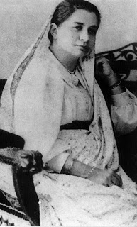
Her speech however was far from demure, as she hurled defiance at the might of British Empire. The audience, captivated by her presence and personality was held spellbound by the sincerity, logic and emotion of her fiery speech. Describing the atrocities of British imperialism and the agony of her countrymen, she appealed to the audience to cooperate in freeing from slavery one-fifth of the whole human race inhabiting that oppressed country. With a dramatic gesture, amid thunderous cheers, she unfurled a tri-colour flag.
That lady, who dared to defy the might of an Empire, who made history by unfurling India's first national flag on foreign soil and thus succeeded in focusing world attention on India’s plight, was an Indian Zarathushti from Mumbai, Bhikaiji Rustom Cama. She was recognized as one of the outstanding Indian revolutionaries in Europe, who came to be known as the High Priestess of Indian nationalism. Her portrait appeared in French newspapers along with Joan of Arc.
Bhikhaiji was born into an affluent Parsi Zoroastrian family in Bombay, to Sorabji and Jaijibai Patel, and was educated at the Alexandra Native Girl's English Institution. Her marriage was arranged with Rustam Cama, the son of renowned Oriental scholar, Kharshedji Cama, in 1885. Not being content in her household role, she used to say that she was also wedded “to the uplift of my countrymen, both social and political”. An icon of India’s Independence Aspirations.
Enthusiastically following the proceedings of the first session of the Indian National Congress, Bhikhaiji later grasped its importance and opportunity. When the plague epidemic broke out in Bombay in 1896, she committed herself to the task of nursing the sick and dying. Her involvement with the plague victims and her cognizance of the suffering caused by famine and economic depression made a deep and lasting impression on her psyche. She became involved in politics and determined to fight to liberate India from foreign rule.
Due to health problems Bhikhaiji went to England in 1902 to obtain an operation and medical treatment. During her stay abroad, from 1902 to 1907, she underwent a dramatic advance in her political activism, earning the name 'Mother of the Revolution'. She started her political work in England under the guidance of the Grand Old Man of India, Dadabhai Naoroji. She campaigned for Dadabhai's election to the British House of Commons, and met many eminent Indians involved in India's freedom struggle.<> [Source ‘Vohuman.Org’]

Bai Jerbai Nusherwanji Wadia. (1852 – May 1926)
Born and reared into a Zarathushti way of life. Taught at school in the medium of Gujarati, as per the norms of the times, she had the distinction of being offered the services of an English governess, arranged for by her maternal uncle, Rustomji Jamshetji Jeejeebhai. It was acknowledged this arrangement would help cultivate her mind in English literature and her stature in society with English mannerisms.
This would, thus, offer her an opportunity to lead a fairly sophisticated social life, well suited to her status and to her share of earning through the entrepreneurial ventures of the family.
Yet, Jerbai had different thoughts. She had secretly harbored a heartfelt desire to offer an opportunity to those Zarathushtis less privileged than her and had searched for means to the furtherance of their lives.
In 1907 Bai Jerbai's husband, Naoroji Nusherwanji Wadia, suddenly died leaving her Rs. 9,00,000 in his will. She realised her first opportunity to offer assistance to the needy of the community. Aware that tenants in Bombay lived under the constant threat of being evicted from rental apartments at short notice & without a guaranteed security and low cost housing in Bombay, not many families would venture to leave their secure homes in Gujarat to come to the big city to better their lot.
Jerbai devised a strategy. She arranged for land to be purchased at Lalbaug, specifically for the construction, initially of 8 low cost rental apartment blocks for these early Zarathushti arriving from Gujarat. She personally supervised the planning of the apartment buildings, a sign of dedicated intent.
She allotted apartments only to those needy families, who could present a valid reason to justify leaving their time-honored joint family homes in Gujarat. She kept a close eye on the welfare and harmony of the families and the maintenance, hygiene and timely repairs of the constructions. After studying the income and family expenditure, she fixed the monthly rental at Rs.9, or Rs.10 or Rs.11 – depending on the size and location of the apartment. On many occasions, she waived the rental for a few months, of those who were unable to meet the monthly payment due to unavoidable circumstances.
After this initial success, Jerbai established the Naoriji Nusherwanji Wadia Building Trust Fund in 1917. She named her eldest son, Khurshetji Wadia (later, Sir Cusrow Wadia), Sir Jamshetji Jeejeebhai, Mancherji Pestonji Kharegat and herself as Trustees for the building and maintenance of further apartments, bringing the total to 32. This housing colony was named ‘Naoroj Baug’ in the memory of her husband.
Later she purchased 40,500 square yards of land adjacent to Masina Hospital to build a colony of 168 apartment blocks to cater for needy Zarathushti families. It was named ‘Rustom Baug’ in the memory of her late son.
On a smaller piece of land available (~13,500 square yards) on the opposite side of the Masina Hospital, conveniently situated near the Byculla Railway station and major bazaar of the district. Here, a colony of 5 large blocks of smaller apartments for 136 families was constructed. But, she did not survive its completion.
She died on 8 May 1926. This housing colony was named ‘Jer Baug’ in her memory.
She was noted for other very generous donations, each one for the worthy cause of health & upliftment of the underprivileged and the needy Parsi women for adequate health care.
Her generous donations in this respect included the building of or extensions to several clinics and hospitals.

1. The extension to the Khandala Charitable Clinic, which was built in 1902 by her late husband.
2. A hostel for Nurses at the Sir Jamshetji Jeejeebhai Hospital in 1903.
3. A charitable Hospital on the grounds of the Bombay Parsi Panchayat at Chowpatty in 1906.
4. An additional block and a new dispensary for the Dr. Bahadurji Sanatorium in Deolali in 1909.
5. A block at the Jehangir Marzban Convalescent Home in Khandala.
6. The building of Dr. Rustom Billimoria T. B. Sanatorium for Zarathushtis.
7. Annual grants of Rs. 5,000 to the Dr. Tehmulji Narimanwalla Obstetrics Hospital plus a donation of Rs. 51,000 in
. the Endowment Fund giving a 3.5% annual interest to the Hospital.
8. A grant of Rs. 5000 to the Parsi General Hospital.
9. A grant of Rs. 25,000 to the Bandra Shirinbai Cama Convalescent Home.
10. A grant to the Mahableshwar Parsi Gymkhana and the building of Badminton Court.
It is also of importance to note that her dream, which touched the lives of thousands of Zarathushtis, was through her influence, kept alive by her two sons, Sir Cusrow Wadia (born 1869) and Sir Ness Wadia (born 1873) after she passed away. Among their many important contributions was the building of housing colonies of ‘Cusrow Baug’, ‘Ness Baug’ and ‘The Bai Jerbai Wadia Hospital for Children’. (Above excerpt from article by Dr. Sam Kerr)
References from: Parsi Prakash: Annual Vol. of 1823 & 1826. – 'Parsi Lustre on Indian Soil': Vol. 1 – FEZANA Vol. IX 1996.
→ Article – ‘The Wadias of India: Then & Now’ by Khorshed Jungalwala. – Available by request. (File Size – 170KB)

Cornelia Sorabji (Nov.1866 – July 1954)
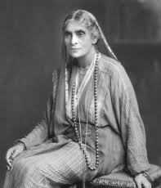
She was the first female barrister from India, a social reformer, and a writer. She was also the first female graduate from Bombay University, and the first woman to read law at Oxford.
Sorabji was born at Nashik in the Bombay Presidency, India, on 15 November 1866. She was one of nine children of Reverend Sorabji Karsedji, a Parsi Christian, and his wife, Francina Ford, an Indian who had been adopted and raised by a British couple. Ford, who believed that education, must begin at home with women, helped to establish several girls' schools in Poona (now Pune).
Due in part to her influential social position, Ford was often consulted by local women in matters pertaining to inheritance and property rights. Many of Sorabji's later educational and career decisions would be heavily influenced by her mother.
As a child Sorabji received her education both at home, with her missionary father, and at mission schools. In 1892, she was given special permission by Congregational Decree, due in large part to the petitions of her English friends, to take the Bachelor of Civil Laws exam at Oxford University, becoming the first woman to ever do so.
Legal activities
Upon returning to India in 1894, Sorabji became involved in social and advisory work on behalf of the purdahnashins, women who, according to Hindu law, were forbidden to communicate with the outside male world. In many cases, these women owned considerable property, yet had no access to the necessary legal expertise to defend it. Sorabji was given special permission to enter pleas on the behalf of the purdahnashins before British agents of Kathiawar and Indore principalities, but she was unable to defend them in court since, as a woman, she did not hold professional standing in the Indian legal system. In the hopes of remedying that, Sorabji presented herself for the LLB examination of Bombay University in 1897 and pleader's examination of Allahabad high court in 1899. Yet, despite her successes, Sorabji would not be recognized as a barrister until the law which barred women from practicing was changed in 1924.
Sorabji began petitioning the India Office as early as 1902 to provide for a female legal advisor to represent women and minors in provincial courts. In 1904, she was appointed Lady Assistant to the Court of Wards of Bengal and by 1907, due to the need for such representation, Sorabji was working in the provinces of Bengal, Bihar, Orissa, and Assam. In the next 20 years of service, it is estimated that Sorabji helped over 600 women and orphans fight legal battles, sometimes at no charge. She would later write about many of these cases in her work Between the Twilights and her two autobiographies. In 1924, the legal profession was opened to women in India, and Sorabji began practicing in Calcutta. However, due to male bias and discrimination, she was confined to preparing opinions on cases, rather than pleading them before the court. She retired from the high court in 1929, and settled in London, visiting India during the winters. She died at her London Home, Northumberland House, on 6 July 1954.
Social and reform work
At the turn of the century, Sorabji was also actively involved in social reforms. She was associated with the Bengal branch of the National Council for Women in India, the Federation of University Women, and the Bengal League of Social Service for Women. For her services to the Indian nation, she was awarded the Kaiser-i-Hind gold medal in 1909. Although an Anglophile, Sorabji had no desire to see "the wholesale imposition of a British legal system on Indian society any more than she sought the transplantation of other Western values." Early in her career, Sorabji had supported the campaign for Indian Independence, relating women's rights to the capacity for self-government. Although she greatly supported traditional Indian life and culture, Sorabji did a great deal to promote the movement to reform Hindu laws regarding child marriage and the position of widows. She often worked alongside fellow reformer and friend Pandita Ramabai. Nevertheless, she believed that the true impetus behind social change was education and that, until the majority of illiterate women had access to it, the suffrage movement would be a failure.
By the late 1920s, however, Sorabji had adopted a staunch anti-nationalist attitude; believing that nationalism violated the beliefs, customs, and traditions of the country's Hindu 'orthodox'. By 1927, she was actively involved in promoting support for the Empire and preserving the rights of the Hindu Orthodox. She favorably viewed the polemical attack on Indian self-rule in Katherine Mayo's 1927 book Mother India, and condemned Mahatma Gandhi's campaign of civil disobedience. She toured India and the United States to propagate her political views which would end up costing her the support needed to undertake later social reforms. One such failed project was the League for Infant Welfare, Maternity, and District Nursing.
Bibliography
In addition to her work as a social reformer and legal activist, Sorabji wrote a number of books, short stories and articles & two autobiographical works entitled India Calling (1934) and India Recalled (1936). It is acknowledged that she contributed to Queen Mary's Book of India, 1943, which had contributions from T. S. Eliot and Dorothy L. Sayers.

Sir Dhunjibhoy Bomanji. (1862 – 1937)
This great man amassed a fortune; from very scanty sources. It appears he had a huge labour force in the Bombay dockyards, and probably other businesses, as his colorful and lavish lifestyle attests to a considerably huge fortune.
In his later years, with some back problems, he is said to have ordered a custom built Rolls Royce with a high roof, so he could get in without bending! At a charity even in UK, he became the highest bidder for the donation sought from the wealthy persons gathered there, and got to plant a kiss on the forehead of the famous actress Greta Garbo!
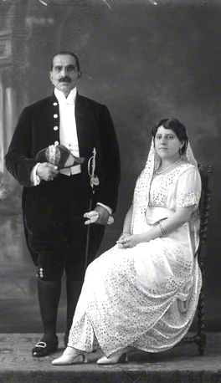
The statue of a famous British general at the entrance of Edinburg Castle in Scotland, one Earl Haig, was erected there from his donation. He was obviously a well-known donor then, both in India and abroad, but little is now known because he never organised his charities. But Parsis seem to have forgotten his greatest singularly exemplary service to the Parsi community at a time of crisis. It makes for interesting reading:
When King George V visited India, (Dec. 1911) the Parsis, much against the general declaration by a majority of Indians to boycott the event, went to welcome the King. This caused great anger amongst people in Bombay, and started a riot against the Parsi community.The riot lasted for several days, and angry crowds threatened to forcibly enter various Fire temples to cause damage, and knowing the Parsis do not allow entry to others. Sir Dhunjibhoy Bomanji rose to the occasion and ordered his dockyard labour force along with all those Zoroastrians, especially those Parsis then engaged in manual jobs, thus tough men, to protect the temples from looting and desecration. He provided them with necessary arms allowed to civilians then, probably bamboo sticks and other defensive items, and food and provisions to stand guard at the various Fire Temple entrances.
He would personally tour all the temples throughout Bombay, at night, taking along the Police Commissioner with him. The temples were safeguarded and no fire or damages by rioting crowds on account of the arrangements made by this great man. Today, very few Parsis’ remember him.*
When the Prince of Wales (later King Edward VIII, who abdicated the throne) landed in Bombay on 17th November, 1921. At that time Mahatma Gandhi had given a call to boycott all official functions connected with the Prince's visit. This was one time that Hindu and Muslims were together!
Over the centuries after we landed in India, the Parsis believed in owing their allegiance to who ever were in power. Accordingly, they believed it was their moral obligation to welcome the Prince.
Boy Scout groups were in vanguard and Parsi ladies also took
Sir Dhunjibhoy Bomanji & Lady Dhunjibhoy Bomanji leading part in welcoming the monarch. Naturally, this was not
© National Portrait Gallery, London. by Bassano palatable with the satyagrahis and they began targeting Parsi
Institutions and businesses.
Since they believed that the most sacred institutions to the Parsis were their Fire Temple's; they started attacking them! At that time there were about six Parsi crorepathis (very rich person) and all of them fled Bombay to their summer homes at Khandala, Lonavla, and Mahableshwar etc. But, in stepped a saviour who thought it was his duty to save our Fire Temples as also the Parsi community.
Dhunjibhoy was well known in the Bombay social circle at that time, so he immediately requested the Police Commissioner to provide armed police personnel to guard our Fire Temples. The Police Commissioner declined saying the full Police Force were on Bandobast duty for the Prince's visit. He however agreed to provide for arms and amunation. Ultimately, Dhunjibhoy took up on himself to the task to arrange for providing security at Fire Temples, especially in the Grant Road area. Old timers recall that in the Dhobi Talao area were all our Atash Behrams were situated, he had arranged with the Irani restaurant owners (i.e. Alfred, Kyani, and Bastani) to provide food to all Parsi stalwarts who were stationed at the Atash Behrams with arms, at his own expense. A few Parsis were killed. These were the last major riots where Parsis were participants. It is one chapter in Parsi history that the community has chosen to forget. Mahatma Gandhi was ashamed of the action of the people and went on a fast.
A valiant hero of the Parsi community has passed into history unsung. Today, whatever we Parsis are is because of Dhanjibhoy's courage & gallantry. <>
* ‘Sir Dhunjibhoy Bomanji’ Full write-up with UK photographs. – Available by request. (File Size - 380KB)

Field Marshal – SAM H.F.J. MANEKSHAW. (3 April 1914 – 27 June 2008) ‘An Officer and a Gentleman.’
(India Today – 30th Anniversary Issue - 26 Dec. 2005)

I first heard about the Field Marshal as a schoolboy in Jammu where he was commanding the Tiger Division. He had a handsome and flamboyant personality with a rare and distinguished charisma. He endeared himself to everyone, from a sepoy to a general, with his humility and humane outlook on life.
General Manekshaw would often go for a walk in the evening towards the officers' transit camp in Jammu. On one such visit, he came across a young officer returning from leave and struggling with his luggage. On finding him in a spot, Sam Bahadur, as he was lovingly called, then in his civvies, promptly helped the officer carry his bags to the transit camp. The guards on duty smartly saluted their general officer. A bit surprised, the young officer guardedly enquired of him, "Thank you, sir. Who are you?" Sam replied, "Oh, I help soldiers like I just did, and in my spare time, I command the division."
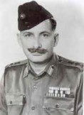
After being commissioned in the army, I served under the Field Marshal when he was the commander of the Eastern Army. At that time, I was with my battalion in Nagaland. It was during this tenure that I imbibed the counter-insurgency philosophy outlined by Sam, which was based on a humane approach and was aimed at winning the hearts and minds of the Nagas. The success of his combat philosophy was evident when we conducted an operation to trap an infiltrating insurgent group led by the self-styled Naga general Mowu Angami. Intelligence poured in from local people at all stages of the operation thanks to our people-friendly approach. The operation was a major success and left an indelible impression on my mind. To an extent, the central theme of my counter-terrorist operations is inspired by this approach.
In early 1971, a cabinet meeting was in progress after the crackdown in Bangladesh by the Pakistani forces. Indira Gandhi was in the chair with senior cabinet ministers. The then chief of army staff was an invitee. Mrs Gandhi was furious about the continuous and frantic reports of refugees pouring into the border states of West Bengal, Assam and Tripura, and wanted immediate intervening military action. Rather than toeing her line as most would have done in his place, the chief had the presence of mind and, most importantly, the moral courage to reply, "Prime minister, that would mean going to war, and we are not ready at the moment."
Thereafter, he listed the advantages of going to war at a later date and was able to convince the prime minister. That was Sam. After the setbacks suffered in 1962 on the Sino-Indian border and the successes of the 1965 conflict with Pakistan, the Indian Army rallied under Sam to give the nation its finest hour. He masterminded a brilliant, 14-day military campaign to achieve victory and liberate Bangladesh. His stoic insistence on buying time to prepare the army resulted in the historic win and surrender of 93,000 Pakistani troops, a record in the annals of military history. It is also his greatest contribution to the nation and the armed forces.
Sam can disarm the most hostile crowd with a smile, forthright style and wit. He was and remains a soldier's general, who can identify with the rank and file of the organisation. He is also a great communicator and can hold the attention of any group. It is said that old soldiers never die, they just fade away. I am sure Sam won't. He will continue to charm us with that twinkle in his eye, rekindling hope. Ninety years young, he will remain the epitome of an officer and a gentleman, carrying the spirit of soldiering from the past, reliving it in the present and preserving it for the future.

BIO-DATA – Field Marshal Sam Manekshaw.

- Born in Amritsar, Punjab in 1914.
- First Field Marshal of India
- Led India to victory in 1971 war

- 2005 lived alone in Kunnoor with his favourite Gorkha retainer.
- Awarded the Military Cross – 1942
- Had a keen interest in gardening &had tried his hand at cooking.

His Quotable quote. “If a man says he is not afraid of dying; then he is either lying or he is a Gorkha”

J. J. Singh. –Chief of Army Staff.

MEMO:
"The only time I met Sam Manekshaw was when I was a Cdr in 1972. I passed by him and saluted him indoors in South Block in Delhi. He stopped and spoke to me saying that I was the only naval officer who had saluted him indoors! I replied that we in the Navy were not supposed to salute indoors but I had made an exception for him. He was happy, shook my hand and left. He looked prim and proper and walked ramrod erect.
Below is an anecdote about him which might be of interest. – There are not many people like him."

Capt Mohan Ram (IN)

An anecdote between Indira Gandhi P.M. and General Sam Bhadur Manekshaw – April 1971 *

There is a very thin line between being dismissed and becoming a Field Marshal.
In 1971, when Pakistan cracked down in East Pakistan, hundreds and thousands of refugees started pouring into India, into West Bengal, Assam and Tripura. The Prime Minister held a Cabinet meeting in her office. The External Affairs Minister Sardar Swaran Singh, the Agriculture Minister, Mr. Fakhruddin Ali Ahmad, the Defence Minister, Babu Jagjivan Ram and the Finance Minister, Yashwant Rao Chavan were present. I was then summoned.
A very angry, grim-faced Prime Minister read out the telegrams from the Chief Ministers of West Bengal, Assam and Tripura. She then turned around to me and said, "What are you doing about it?"
I said, "Nothing, it's got nothing to do with me. You didn't consult me when you allowed the BSF, the CRP and RAW to encourage the Pakistanis to revolt. Now that you are in trouble, you come to me. I have a long nose. I know what's happening."
I then asked her what she wanted me to do. She said, "I want you to enter Pakistan."
And I responded, "That means war!"
She said, "I do not mind if it is war."
"Have you read the Bible?" I said.
The Foreign Minister, Sardar Swaran Singh asked, "What has Bible got to do with this?"
I explained, that the first book, the first chapter, the first words, the first sentence God said was, "Let there be light" and there was light. Now you say, "Let there be war" and there will be war, but are you prepared? I am certainly not. This is the end of April. The Himalayan passes are opening and there can be an attack from China, if China gives us an ultimatum.
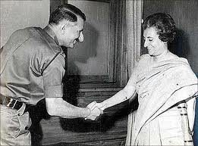
The Foreign Minister asked, "Will China give an ultimatum?" And I said, "You are the Foreign Minister, you tell me". I told them that my armoured division and two of my infantry divisions were away. One in the Jhansi / Babina area, the other in Samba and the third one in Andhra Pradesh and Tamil Nadu. I mentioned that I will require all the road space, all the railway wagons, the entire railway system to move these formations to the operational areas and that harvesting was in progress in the Punjab and UP and they would not be able to move the harvest which would rot; and I pointed out to the Agriculture Minister that it wouldn't be my responsibility if there was a famine. Then I said, "My armoured division, which is my big striking force is supposed to have 189 tanks operational. I have got only 11 tanks that are fit to fight."
The Finance Minister, who is a friend of mine asked, "Sam why only 11?" So I told him, "Because you are the Finance Minister. I have been asking you for money for over a year and you say you haven't got it!"
And finally I turned around to the Prime Minister and said that the rains were about to start in East Pakistan and when it rains there, it pours and when it pours, the whole countryside is flooded. The snows are melting, the rivers would become like oceans. If you stand on one bank, you can't see the other. All my movement would be confined to roads. The Air Force, because of climatic conditions would not be able to support me. Now Prime Minister, give me your orders. The grim Prime Minister with her teeth clenched said, "The Cabinet will meet again at four o'clock".
The members of the Cabinet started walking out. I being the junior most was the last to go and as I was leaving, she said, "Chief, will you stay back?"
I turned around and said, "Prime Minister, before you open your mouth, may I send you my resignation on grounds of health, mental or physical?"
She said, "Every thing you told me is true".
"Yes! It is my job to tell you the truth" I responded, "and it is my job to fight, it is my job to fight to win and I have to tell you the truth."
She smiled at me and said, "All right Sam, you know what I want?"
I said, "Yes, I know what you want!"
========
Three cheers to the old soldier.
*From: Field Marshal K M Cariappa – Memorial Lectures 1995-2000 [Lancer Publishers & Distributors, Delhi]

Links:
- http://en.wikipedia.org/wiki/Sam_Manekshaw
- http://www.youtube.com/watch?v=XWAuVJBom9I
-http://defenceforumindia.com/forum/politics-society/42172-field-marshal-sam-manekshaw-s-lecture-leadership-discipline.html

Sir Pherozeshah Mehta (1845-1915)
Sir Pherozeshah Mehta was born in Bombay, on August 4, 1845, where he spent the greater part of his life. His father, Merwanji Mehta, belonged to a family of merchants. Pherozeshah entered the Lincoln's Inn in 1864 and spent three years qualifying himself. Called to the Bar in 1868, he left for home in September 1868.
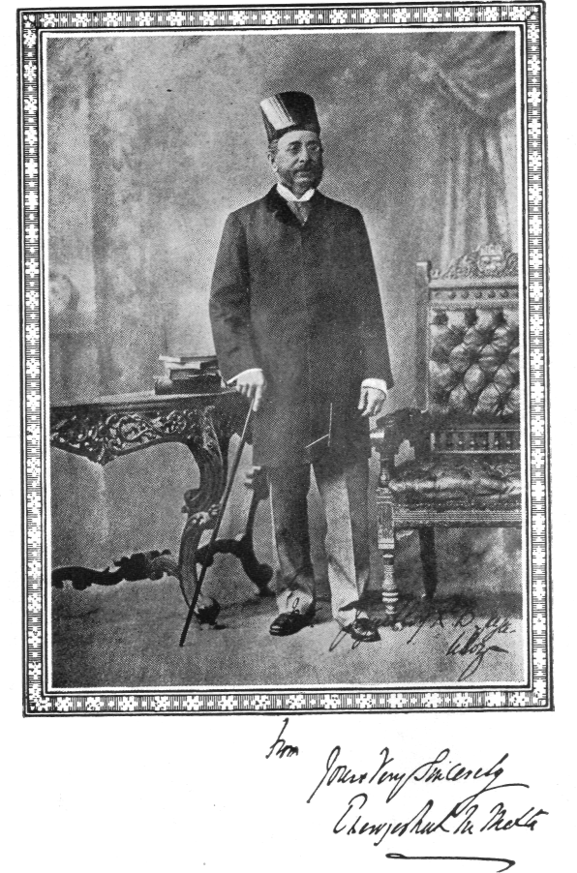
While in England, he used to frequent the house of Dadabhai Naoroji, and these visits were to remain important influences in moulding his liberal outlook. Several of his close friends were liberals; besides Telang and Badruddin Tyabji (who along with Pherozeshah were described as "the three bright boys of Bombay"), Ranade, Gokhale, Wacha, W. C. Bannerjee and Bal Mohan Wagle were close to Pherozeshah. This made him a part of the Liberal School of Indian politics. His antipathy to violent methods in politics alienated him from Tilak and Pal, his innate trust in constitutionalism, his dislike of regional and communal developments, made him criticise Sir Syed Ahmad Khan. These were characteristics that distinguished the Liberal School in Indian politics.
Education, both primary and higher, absorbed his interests throughout his life. He saw in education the means by which India could modernize itself rapidly; he laid great emphasis on the value of English. He had a hand in the establishment of a Swadeshi Bank, the Central Bank of India.
Pherozeshah is remembered mainly as the maker of the modern Bombay Municipal Corporation which he fostered and served in a distinguished manner for nearly half a century.
He was mainly responsible for the founding of an English newspaper, the Bombay Chronicle (April 1913), which became an important agency for expressing Indian public opinion.
In the nationalist movement, in the forming and running of political associations and in serving Governmental official institutions Pherozeshah had a notable record. In the proceedings of the Indian National Congress (in its founding he had a distinctive hand) he held an important and commanding position.
His main endeavour was to keep the extremists from dominating the Congress, and in this he was largely successful. He presided over the Indian National Congress (INC) session held in Calcutta* (1890) and was twice President of the Reception Committee when the Congress sessions met in Bombay (1889 and 1904). In the different Congress sessions, which he attended, he either moved or supported resolutions for reforming the administration of the country. Along with Telang, he founded the Bombay Presidency Association (1885) and served as its Secretary. Honours came to him thick and fast. He was made a C.I.E. in 1894 & 1904 saw him Knighted.
In 1915 the University of Bombay decided to confer upon him the honorary degree of ‘Doctor of Law’. He was a much admired man. – R. Srinivasan.

From: *The Presidential Address by Pherozeshah Mehta - I.N.C. Session, 1890, Calcutta.

“All movements of the kind in which we are concerned pass through several phases as they run their course. The first is one of ridicule. That is followed, as the movement progresses, by one of abuse, which is usually succeeded by partial concession and misapprehension of aim, accompanied by warnings against taking "big jumps into the unknown". The final stage of all is a substantial adoption of the object of the movement, with some expression of surprise that it was not adopted before.
Well, gentlemen, we have pretty well passed the first two stages. We have survived the ridicule, the abuse, and the misrepresentation. We have survived the charge of sedition and disloyalty. We have survived the charge of being a microscopic minority. We have also survived the charge of being guilty of the atrocious crime of being educated, and we have even managed to survive the grievous charge of being all Babus in disguise.”

→ Article – ‘List of Notable Parsis’ (with links to their life) – Available by request. (File Size - 1.0MB)
→ “ “ – ‘Prominent Zarathushties of India’ (with links to their life) – Available by request. (File Size - 400KB)
→ “ “ – ‘PARSIS’ The World’s Smallest Nation’ – Available by request. (File Size – 1.7MB)

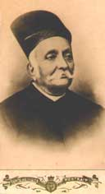
Sir Dinshaw Manockjee Petit (first Baronet), 1823-1901
A patriot, pioneer and benefactor, Sir Dinshaw Manockjee Petit, first Baronet was born on 30th June 1823 in his maternal grandfather Jejeebhoy Dadabhoy’s house at Bora Bazar Street, Fort, Mumbai. As the eldest son of Manockjee Nusserwanji Petit, he married Sakarbai (nee Panday) in 1837. The couple had fourteen children were born to them – six sons and eight daughters. He was considered an orthodox and religious Parsi.
He started life as an apprentice on a salary of Rs.15/- per month. His keen business acumen is something he must have inherited from his father who was a practical businessman. Starting as a broker he gradually turned to manufacturing. In 1854 he was appointed an officer of the Grand Jury. He was the first to introduce looms for a weaving mill in the whole of India in 1855. He was also the pioneer of dyes industry. In 1859 he donated Rs.25, 000/- to charity when his father passed away. In 1860 he became the doyen of the textile industry. In the same year he started Manockjee Petit Spinning and Weaving Company.
He bought the Bombay Hydraulic Electric Press Company for Rs.6,65,000/-. In December 1865 he purchased a steamer called "Romania" for Rs.75,000/-. In 1865 at Sir Dinshaw Petit, (1st Baronet) the end of the American Civil War many persons were bankrupt in the share mania. He not only wrote off debts worth Rs.30 lacs but also provided funds and employment to people in distress. Between 1870 and 1875 he and his brother Nusserwanji owned 17 mills. In 1875 he founded the Bombay Mill-owners Association and was its chairman from 1879 to1894. Between 1884 and 1898 the number of mills nearly doubled from 43 to 82, and the number of textile workers jumped from 36,000 to 71,000.
Dinshaw was appointed a Justice of Peace (JP) in 1860 and also became a Trustee of the Bombay Parsee Punchayet and Sir J.J. Parsee Benevolent Institution at the young age of 37. He served as a trustee for 41 years, the longest serving trustee.
As a great captain of industry, Dinshaw also became a director of the Bank of Bombay, the Bombay Fire Insurance Company, the Hyderabad Spinning and Weaving Company. He was the founder and trustee of the Persian Zoroastrian Amelioration Fund, its chairman from 1876 and its treasurer from 1885. Due to his perseverance from 1861 to 1882 the Jizya tax was abolished bringing relief to destitute Irani Zoroastrians. He was the committee member of the Bombay Association from 1862 and its chairman from 1878, the Society for the relief of Destitute Irani Zoroastrians in Bombay, the Society for Prevention of Cruelty to Animals, a member of the Royal Asiatic Society and The Sassoon Institute.
He was appointed a Sheriff in 1886. On the occasion of his being conferred the knighthood in February 1887 he presented clothes to 8000 employees in the mills under him. On 14th April 1887 the Illustrated London News published his portrait with a brief biography. In June of the same year, he donated £ 1000 each to the proposed Imperial Institute and Northbrook Indian Club Library at London. He was also appointed President of the Gaurakshak Mandali established in Bombay. In December of the same year he was appointed an official of the Viceroy's Legislative Council, the first Parsi to receive this honour. In January 1888 he was appointed a Fellow of the Bombay University in the faculties of Arts and Engineering.
His wife Lady Sakarbai passed away on 5th March 1890 after a long and happy married life of 53 years. At her Uthamna the family donated Rs.1,12,000/- to charity. A few days later Queen Victoria made him a Baronet. He entrusted to the Government Municipal Bonds worth Rs.25 lacs to perpetuate the Baronetcy. The Legislative Council of India passed the 6th Act of the Baronetcy Act of 1893 on March 9, 1893. Naser-ul-Din Shah of Persia presented him with a Royal Diploma and conferred on him the title of “Shero Khurshid” in 1892.
A great philanthropist, his public and private benefactions amounted to nearly Rs.34 lacs, and all directed towards religious, educational, commerce, medical and other philanthropic purposes. In 1862 he donated Rs.8,500/- to a fund for relief of poor weavers of Lancashire in 1889 he donated Rs.300,000 for land and buildings for the founding of the Victoria Jubilee Technical Institute (VJTI). During his life time he Total of Rs.34,17,036/- in charitable donations.
A magnificent life-size statue of his, in marble stands at Tairsee Bhatia Baug (opposite the head office of the Central Railway, Chhatrapati Shivaji Terminus, V.T.) With the following Inscription:

Sir Dinshaw Manockjee Petit – 1st Baronet.
Erected by the Public of Bombay
In appreciation of the distinguished and valued
Services rendered by him as a great
Philanthropist and captain of industry
Born:30th June 1823 - Died:5th May 1801

An excerpt from an article written by Mr. Giara,Marzban, in observation of death centenary of Sir Dinshaw Petit in June 2001.
→ Article – ‘Sir Dinshaw Petit – First Baronet’ – Available by request. (File Size – 76KB)

Homi Jehangir Bhabha (30 Oct. 1909 – Jan. 24, 1966)
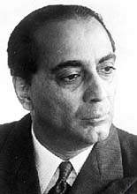
Homi Bhabha was born in a wealthy Parsi family of Bombay. His family had a long tradition of learning and service in the field of education. His grandfather, also named as Homi Jehangir Bhabha, was the Inspector General of Education in the State of Mysore. Bhabha's father Jehangir Hormusji Bhabha was educated at Oxford and later qualified as a lawyer. His mother Meheren was grand-daughter of Sir Dinshaw Maneckji Petit, widely respected in Bombay for his philanthropic endowments. His grandfather Hormusji's sister, that is, Bhabha's paternal aunt Meherbai married, Sir Dorab J. Tata (1859-1932) the oldest son of Jamshetji Nusserwanji Tata.
Bhabha is mostly known as the chief architect of India's nuclear programme. However, his contribution to India's development goes far beyond the sphere of atomic energy. He had established two great research institutions namely the Tata Institute of Fundamental Research (TIFR), and the Atomic Energy Establishment at Trombay – after Bhabha's death was renamed as the Bhabha Atomic Research Centre.
He played a crucial role in the development of electronics in India. Bhabha was an outstanding scientist and a brilliant engineer. He derived a correct expression for the probability of scattering positrons by electrons, a process now known as Bhabha scattering. His classic paper, jointly with W. Heitler, published in 1937 described how primary cosmic rays from space interact with the upper atmosphere to produce particles observed at the ground level. Bhabha and Heitler explained the cosmic ray shower formation by the cascade production of gamma rays and positive and negative electron pairs. 'In 1938 Bhabha was the first to conclude that observations of the properties of such particles would lead to the straightforward experimental verification of Albert Einstein's theory of relativity'.
Bhabha possessed sensitive and trained artistic gifts of the highest order. The environment in which he grew certainly helped him to develop all these fine qualities. He loved music and dancing. He had considerable knowledge of both Indian and western music. He painted and sketched. He designed the settings of dramatic productions. He was an architect of no mean ability. Bhabha was a perfectionist. He was a true lover of trees and did everything under his powers to protect them. In his tribute paid to Bhabha, Lord Redcliffe-Maud has aptly described the different facets of Bhabha's personality:
"Affectionate and sensitive, elegant and humorous, dynamic and now dead. Homi was one of the very few people I have ever known (Maynard Keynes was another) who enhance life whatever the context of their living. In Homi's case this was because he was fantastically talented but so fastidious about standards that he was never a dilettante. Whatever he set himself to do he did as a professional – but one who worked for love. He was relentlessly creative, enhancing life because he loved all forms of it. So he became a living proof that scientific excellence can go with excellence in arts and racial differences need be no bar to friendship…….”

Bhabha attended the Cathedral and John Connon Schools in Bombay. After passing Senior Cambridge Examination at the age of 15, Bhabha entered the Elphinstone College in Bombay and later the Royal Institute of Science, also in Bombay. In 1927 Bhabha joined the Gonville and Caius College in Cambridge, the same college where his uncle Sir Dorab J. Tata had studied and who made a donation of twenty-five thousand pounds to the college in 1920. He took the Mechanical Sciences Tripos in 1930. It may be noted here that both his father and his uncle Sir Dorab J. Tata wanted Bhabha to become an engineer with the view that ultimately he would join the Tata Iron and Steel Company at Jamshedpur. At Cambridge Bhabha's interests gradually shifted to theoretical physics. In 1928 Bhabha in a letter to his father wrote: "I seriously say to you that business or job as an engineer is not the thing for me. It is totally foreign to my nature and radically opposed to my temperament and opinions. Physics is my line. I know I shall do great things here.
The important contributions made by Homi Bhabha while working at Cambridge, have been summarised by G. Venkataraman (in his book, Bhabha and His Magnificent Obsessions, Universities Press, Hyderabad, 1994) as:
- The explanation of relativistic exchange scattering (Bhabha Scattering).
- The theory of production of electron and positron showers in cosmic rays (Bhabha-Heitler theory).
- Speculation about the Yukawa particle related to which was his suggestion of the name meson.
- Prediction of relativistic time dilatation effects in the decay of the meson.
Bhabha was elected a Fellow of the Royal Society in 1941. In 1943 he was awarded the Adams Prize by the Cambridge University for his work on cosmic rays, and in 1948 the Hopkins prize of the Cambridge Philosophical Society. In 1963 he was elected Foreign Associate of the U.S. National Academy of Sciences, and Honorary Life Member of the New York Academy of Sciences. In 1964 he was made Foreign Corresponding Academician of the Royal Academy of Sciences, Madrid. From 1960 until 1963 he was President of the International Union of Pure and Applied Physics. He was president of the historic International Conference of the Peaceful uses of atomic energy held, under U.N. auspices, at Geneva in August, 1955. Bhabha was President of the National Institute of Sciences of India in 1963 and President of the Indian Science Congress Association in 1951. He was awarded the title of Padma Bhushan by the Government of India in 1954.
Bhabha was killed in an air-crash near Mont Blanc peak of the Alps on January 24, 1966, while he was on his way to Vienna to attend a meeting of the Scientific Advisory Committee of the International Atomic Energy Agency.<>
Excerpt from the article by Dr Subodh Mahanti. →Full Article – Homi J. Bhabha – Available by request. (File Size – 76KB)
Dastoor Meherji Rana (1510-1591)
In Navsari a boy was born in into a priestly family from the Kaka Pahlan pol. (pol.= panthaks or districts). This boy was given the name Mahyar, the son of Rana Jesang, and he came to be known as Mahyar (Meherji) Rana. Meherji Rana, who was adopted into the priestly lineage of his paternal uncle (kākā) Vaccha Jesang; who was a man renowned for his piety and learning, and his fame was widespread.
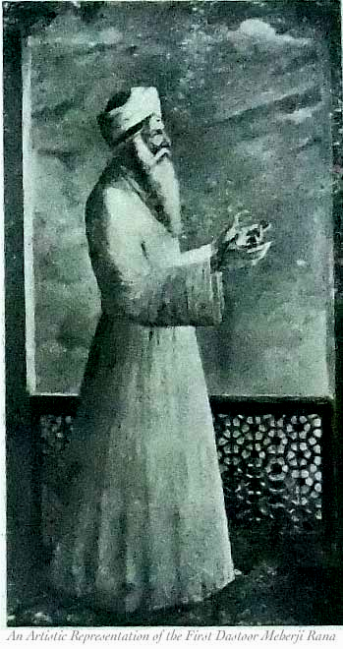
According to a Persian biography in the library's possession, the Māhyārnāma (Manuscript F-81), Meherji Rana was chosen by the Mughal governor at Surat to have an audience with the Emperor Akbar to explain the Zoroastrian religion. During his stay at the court from 1578-9 AD, Meherji Rana impressed the emperor so much that according to the Mughal court historian Abd al-Qādir al-Badā‘ūnī, the emperor ordered his vizier Abu al-Fazl to keep a fire burning day and night at the court. Before Meherji Rana left the court, he was presented with a jāgīr or land grant by the emperor, receiving property in an area called Ghelkhadi, near the modern town of Navsari.
Meherji Rana’s presence in Akbar’s court was a great historic incident for not only the Parsis of Navsari, but for the whole Parsi community. Appreciating this, when he returned to Navsari, all the priests accepted him as the head of the Navsari priesthood, and for the first time the title of high priest (vaḍā dastur) was bestowed. Therefore, he became famous as the First Dastoor Meherji Rana, beginning a priestly lineage which continues to the present day. For almost 50 years (1960-2010), the Navsari community was served by Marhum Dastoor Meherji Kekobad Dastoor Meherji Rana, the sixteenth member of the Meherjirana family to bear the title Dastoor. On January 25, 2010, Kaikhushroo Navroze Dastoor was chosen as the seventeenth Dastoor Meherji Rana.
The ‘Meherji Rana Library’ in Navasari is named for one of the most significant figures in the history of the Parsi community. After the con-struction of the first library building in 1872, a formal trust deed was drawn up in 1874, and a committee was formed for the management of the library. From its very beginning, the Library has been cosmopolitan and has served all the communities of Navsari.
The library was visited by international scholars interested in Zoroastrianism from a very early date, and to this day, the library's guestbook is virtually a "Who's Who" of Zoroastrian studies.

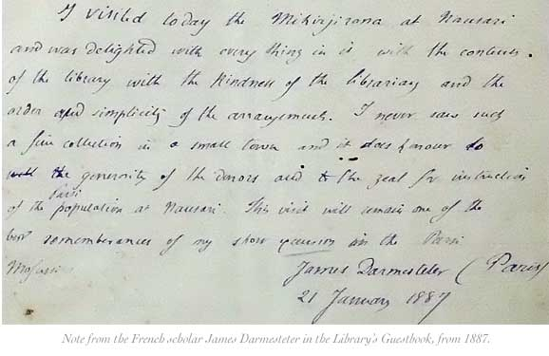I visited today the Meherji Rana at Navsari and was delighted with every thing in it with the contents of the library with the kindness of the librarian and the order and simplicity of the arrangements. I never saw such a fine collection in a small town and it does honour to the generosity of the donors and to the zeal for the instructions of the Parsi population at Navasari. This visit will remain one of the best remembrances of my short journey in the Parsi Mofussil.
James Darmesteter (Paris)
21 January 1887
Shams-Ul-Ulama – Dr. Sir Ervad Jivanji Jamshedji Modi. (26 Oct.1854 – 28 March 1933)
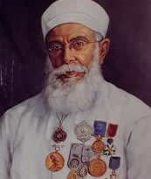
Jivanji was brought up in the midst of a religious atmosphere of an agiary (fire temple). His father, Ervad Jamshedji Jivanji Modi (1807-1871) was the first panthaki of Seth Jejeebhoy Dadabhoy Agiary at Colaba from 1836 to 1871. Ervad Dr. Sir Jivanji Modi served as a panthaky of Seth Jejeebhoy Dadabhoy Agiary from 1871 to 1910 – for nearly forty years.
He grew up as a simple, straightforward man. Science was his first love. He was a wonderful disciple of the famous oriental scholar Kharshedji Cama. It was Kharshedji Rustomji Cama who made him take up Iranian Studies as his second love. He was an all rounder, a genius. He had two loves – nature and books.
Jivanji’s principle was simple living and high thinking. He was an unassuming soul. He took to the path of knowledge as a mission. Though he achieved universal fame, he was a humble man. He remained a student and a researcher all his life. His scholarship encompassed the whole canvas of life.
He was a preacher par excellence. He led an exemplary life. He lived in the world but did not become of the world. He practiced simple living and high thinking. He lived according to the teachings of prophet Zarathushtra and spread happiness by serving humanity.
Honours & Awards.
He was perhaps the most decorated Zoroastrian priest in history. Awards, academic & meritorious were showered upon him.
B.A. (Bombay University, 1876); Fellow of the University of Bombay (1887); Dip. Litteris et Artibus (Sweden, 1889); Shams-Ul-Ulama (Government of India, 1893); Officier d’Academie (France, 1898); Officier de l’Instruction Publique (France, 1903); Ph.D. (Honoris Causa, Heidelberg, 1912); Honorary Correspondent of the Archaeological Department of the Government of India (1914); C.I.E. (1917); Campbell Medalist B.B. Royal Asiatic Society (1918); Honorary Member of the Bhandarkar Oriental Research Institute (1923); Chevalier de Legion d’Honneur (France, 1925); Officier de Croix de Merit (Hungary 1925); Knighted in 1930; LL.D. (Honoris Causa, Bombay University 1931).
He served as Secretary of the Bombay Parsi Panchayet for 37 years managing estates and funds valued at crores of rupees.
Jivanji as an author and orator.
He cultivated his talents for writing and elocution. He was a prolific writer & wrote 70 books – 20 in English, 3 in French, 41 in Gujarati and 6 Memorial Volumes. He also wrote innumerable essay, articles and research papers on a wide variety of diverse subjects ranging from anthropology, geography, history, meteorology, nature, wine and Zoroastrianism.
His most notable contribution to Oriental scholarship was 127 papers read before the Bombay Branch of the Royal Asiatic Society and Anthropological Society of Bombay. His life and his writings will continue to inspire scholars and fellow men.
He was an erudite public speaker. He had delivered over 350 lectures within a span of 45 years i.e. between 1888 and 1933.
A world traveller.
In 1889 he had visited Europe, America, Burma, Vietnam, China and Japan. In 1907 he visited Vyara, Songadh along with scholars Ervad Edulji K. Antia and Pallonji B. Desai.
In 1925 at the age of 71 he visited Egypt, England, Scotland, France, Spain, Germany, Hungary, Switzerland, Russia and Iraq. He was the first Parsi priest to have visited England and Sir George Birdwood considered it a great event when Jivanji dined with him at his house.
A special Convocation of the Bombay University was held on 17th August 1931 when Sir Ernest Hotson, the Governor as Chancellor of the University conferred the Doctor of Laws (LL.D.) honorary degree on the following:
The Right Hon’ble Sir Dinshaw Fardunji Mulla, Sir C. V. Raman, Sir M. Visveswarayya and Sir Jivanji Jamshedji Modi. Sir D. F. Mulla and Sir Jivanji Modi were the first two Parsis to receive this honour.
He was very fond of travelling. He wrote and published an account of his travels. He was a great walker and cyclist. He rendered assistance to scholars. He was a useful, noble gentleman who brought glory to his community. He led a true Zoroastrian life and possessed all virtues desired in a religious leader. His simplicity was an inspiration to all Zoroastrians. He passed away at the age of 78 on 28th March 1933.
To modern man who often complains of not having enough time, Sir Jivanji’s illustrious and noble life is a shining example of how one man in one life can find the time to pursue his interests and also render public service. The lives of great men are the best teachers of humanity.
It is a misfortune that the present day younger generation knows so little about the stalwarts of yore. Plutarch was right when he said, “To be ignorant of the lives of the most celebrated men of antiquity is to continue in a state of childhood all our days.” (An excerpt - From the series: Prominent Zarthushtis. By: Marzban Giara.)
→ More – ‘Notable - Noteworthy of the Clan’ – look up 2 Vol. Set – ‘Parsi Lustre on Indian Soil’ by H. Darukhanawala.
→ And – ‘Enduring Legacy: Parsis of the 20th Century’ – Edited and published by Nawaz B. Mody - 4 Vol. Set.
→ Also – ‘Prominent Zarathushties of India’ (with links to their life) – Available by request. (File Size - 400KB)

KHARSHEDJI RUSTAMH CAMA, (11 Nov.1831— 20 Aug.1909)
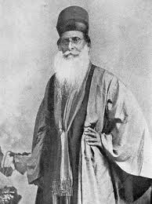
A Parsi Zoroastrian scholar and community leader. He had received a traditional education, and then entered the Elphinstone School, Bombay, from which he was graduated in 1849. In the same year he joined the mercantile firm of a relative at Calcutta, and departed in 1850 for London, but returned to Bombay in 1854. He went to London again in 1855 on a business venture with Dadabhoy Naoroji (who was to be the first Indian elected to Parliament); before returning home, he lingered to study Pahlavi, Avestan, and modern European languages under the Iranists Mohl and Oppert (Paris), Burnouf, and Menant, but especially Spiegel (Erlangen).
Cama had been early attracted by the missionary efforts of John Wilson among the Parsis, but after this experience he resolved to strengthen his community against such incursions through learning. (A series of lectures he read in 1876 on the importance of Zoroastrian education, for instance, was prompted in part by the recent conversion of several Parsi boys to Christianity.)
Upon his return to India, Cama began in February 1861 classes in Avestan, then Pahlavi, first with S. D. Bharucha as teacher; his other early pupils were T. D. Anklesaria, K. E. Kanga, and E. K. Antia. In 1863 he travelled around India and in 1864 founded ‘Zarthoshti Din no Kohl Karnari Mandli’ (Society for the Promotion of Researches on the Zoroastrian Religion).
Parsi Zoroastrian scholar. In 1866 he began publication of ‘Zarthoshti Abhyas’ (Zoroastrian studies), of which twelve volumes appeared. He welcomed James Darmesteter and A. V. Williams Jackson to India. The former called him “le Dastur laïque”; Cama assisted Dastur Dhalla to study under the latter at Columbia University, New York.
Cama worked for the organization of Parsi madressas (madrasas), and his consultation was sought also in the establishment of Hindu and Muslim schools. He was associated with the University of Bombay and helped establish the courses in Avestan and Pahlavi; he served as vice president of the Bombay Branch of the Royal Asiatic Society.
He wrote extensively in Gujarati on Zoroastrianism (a bibliography is given in J. J. Modi, K. R. Cama, Bombay, 1932, pp. 155-56), notably ‘Peqambar Asho Zarthosht na Janmara no Eheval’, (a Life of Zoroaster based on Avestan sources). His English-language works, including translations of Iranica by Rapp, Roth, Spiegel, Rohde, Mordtmann, and Kohut, “The Zoroastrian Calendar,” “A Discourse on Jamshedi Naoroz,” “Freemasonry among the Natives of Bombay” (Cama was a dedicated Mason; the Rustom K. R. Cama Masonic Study Circle, Bombay, is still active), are reprinted in The Collected Works of K. R. Cama, Bombay, I, 1968; II, 1970. J. J. Modi edited The K. R. Cama Memorial Volume, Bombay, 1900; this and S. M. Edwardes, K. R. Cama. A Memoir, 1923, contains biographical data. (J. R. Russell - excerpt)

K. R. CAMA - ON CONVERSION – S. M. Edwards I.C.S. [1923]
In 1903 he (K.R.Cama) played a prominent part in a controversy, which centered round the fundamental question whether the religion of Zarathushtra permits the conversion to Zoroastrianism of persons born in, and belong to, other faiths. The matter, which arose through the conversion of a Christian lady on the occasion of her marriage according to Zoroastrian rites to a Parsi merchant of position and influence, to whom she had already married under French law, was hotly debated by the Parsi Community, the conservatives and orthodox members of which stoutly opposed the admissibility of such conversion to their faith.
K. R. Cama entered the lists, regardless of praise or blame, and pinned his faith to the Avesta of which he was admittedly the ablest exponent. Relying on the teaching of the ancient scriptures, he boldly proclaimed that if any person from a sincere conviction of the truth of the Zoroastrian religion desired to be converted to that faith, there was no ground for refusing to admit such a one, whether man or woman, to the fold. In delivering this message from the Parsi sacred lore, Cama was actually doing violence to his own personal views; for in his opinion it was far better for a man to cling to the religion in which he was born and imbibe its highest teachings, than to enrol himself perhaps for material or worldly reasons, under the banner of another faith. Moreover he was opposed on general grounds to marriages between Zarthostis and those of another creed, believing that such marriages are productive of religious and social incompatibilities, and might, if widely practiced, exercise a detrimental effect upon the matrimonial prospects of Parsi girls.
Despite these views, however K.R. Cama took his stand upon the Avesta; and when in due course a sub-committee, appointed to investigate the question, proposed to put almost insuperable restrictions upon conversion, he wrote a separate minute to the effect that when the sacred and ancient lore permits receiving aliens into the Zoroastrian fold, it is a sin to place unnecessary obstacles in their way, and that so far from making the conditions of conversion restrictive, they should on the contrary be made as little onerous as possible?
[Extract from the book “Kharshedji Rustamji Cama 1831-1909. A Memoir” by S. M. Edwards I.C.S. 1923]

To the previous fourteen ‘noteworthy of yore’ – a Gandhi, we can all be proud off.
The Forgotten Gandhi – THE PIONEER – 22 September 2012 – A SURYA PRAKASH

Feroze Gandhi (12 Sept.1912 – 8 Sept.1960)
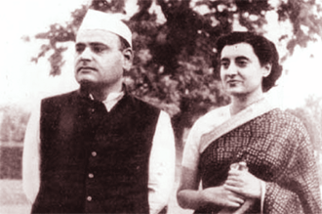
Son-in-law to one Prime Minister, husband to another and father to a third; he should have been a well-known face in the country’s political landscape. But this isn’t the case with Feroze Gandhi, whose birth centenary – Sept. 12 – has just gone unnoticed. India’s greatest investigative parliamentarian, crusader against corruption, advocate of press freedom and the first campaigner for the people’s right to information has gone unnoticed. He was such a cerebral, diligent and ruthless pursuer of truth that he was once described by a fellow Member of Parliament as a “dangerously well-informed person.”
While the nation remains obsessed with the fortunes of the family which has 10–Janpath as its postal address, it appears to have forgotten the real Gandhi who bequeathed this magical surname to Sonia et al.
But why blame the Nation? When the fault lies with an ungrateful Government controlled by this ungrateful family! Last year the Government splurged Rs7.25 crore on newspaper advertisements on the occasion of the birth anniversaries of Indira and Rajiv, but pretends not to notice Feroze’s birth centenary. There may be other reasons for this display of ungratefulness. Since the Government is engulfed in scams and is employing undemocratic means to curtail parliamentary investigations, how can it hail the man who was described as the greatest campaigner against corruption?
Let us leave the Manmohan Singh Government to wallow in its pettiness and pay our tribute to the man who demanded a strong ethical framework for governance during the formative years of our democracy.
Feroze Gandhi began life as a freedom fighter when still in his teens and went to jail on several occasions. He became a member of the Provisional Parliament in 1950 and was elected to the Lok Sabha from Rae Bareli in 1952 and 1957. He emerged as a formidable parliamentarian with his maiden speech on the Insurance (Amendment) Bill in December 1955 in which he exposed the cunning and wicked ways of the proprietors of several private insurance companies. Having done some painstaking research, he held the Lok Sabha enthralled as he narrated story after story about how business barons and companies like the Dalmia-Jain Group played around with the funds of insurers and the web of lies that these companies put out to fool insurers, banks, shareholders and Government. At the end of his narration he demanded strong measures to protect public funds invested in insurance companies, meaning nationalisation of the insurance business. Such was his impact that within two months the President promulgated an Ordinance nationalising the insurance industry. Happy with the outcome, Feroze Gandhi said: “To hold a horse you need a rein; to hold an elephant you need a chain.”
The LIC – Mundhra Scandal.
In November 1957, Ram Subhag Singh and Feroze Gandhi got wind of some shady deals between LIC and HD Mundhra, an industrialist. Singh fired the opening shot via a question in (Lok Sabha) when he asked:

R S Singh: Whether LIC had purchased large blocks of shares from different companies owned by Mundhra?
Deputy Minister of Finance: Towards the end of June 1957, the corporation had invested Rs1,26,86,100. “In concerns in which Shri HD Mundhra is said to have an interest”.
R S Singh: again asked - whether nationalisation of life insurance was not meant to stop such “spurious investments”.
Then Finance Minister – TT Krishnamachari (TTK): rose to say the investments were not spurious. LIC had invested in these companies “solely with a view to getting a return and making a safe investment...”
Feroze Gandhi: May I know whether it is a fact that a few months ago shares were purchased at the higher price than the market price of those very shares on that particular day...?
TTK: … I have been told that no such thing has happened.

These words would soon come to haunt the Minister (TTK) and cost him his job. Through this brief exchange during Question Hour, Singh and Gandhi had laid a neat trap into which the Minister had fallen. As the drama unfolded over the next year in Parliament, people realised the extraordinary power of Parliament and the potential power of an MP.
Dissatisfied with the Minister’s reply, Feroze initiated a Half-Hour Discussion on the subject. He said: “A mutiny in my mind has compelled me to raise this debate. When things of such magnitude, as I shall describe to you later, occur, silence becomes a crime.“ He unfolded the story of murky deals between LIC and Mundhra companies as he attempted to “breach the ramparts” of the Minister’s defence. The Minister had claimed that the Government had no particular interest in Mundhra companies but Feroze showed that over a six month period in 1957, on 19 occasions, LIC had bought shares of the Mundhra Group for Rs1.56 crore. Did this not amount to favouring one individual?
Feroze Gandhi then went on to show how LIC had allowed itself to be cheated. He obtained damning evidence of fraud from the stock exchanges. Shares of Mundhra companies had been artificially jacked up by 30-40 per cent in the week prior to the purchase of shares by LIC.

For example, the share of Osler Lamp Manufacturing Company, which was quoted at Rs2.81 from June 17 onwards, suddenly jumped to Rs4/- on June 24, a day prior to the purchase by LIC. Similarly, the shares of Angelo Brothers, which stagnated at Rs16.87 for a week, jumped to Rs20.25. These purchases were made on June 25 but by the time this debate took place in December, LIC’s Mundhra stocks had depreciated by Rs37 lakh.
Bowing to pressure, the Government announced the appointment of a commission of inquiry headed by Chief Justice MC Chagla of the Bombay High Court. Feroze promptly offered himself as a witness and was the first to testify. Justice Chagla upheld Feroze’s contentions and said that the Finance Minister should take constitutional responsibility for what had happened. — Finance Minister TTK tendered his resignation.
The most extraordinary aspect of Feroze Gandhi’s work was the forensic precision with which he collected facts and the manner in which he marshalled his arguments. While MPs do not exert themselves to obtain facts even in this Internet age, Feroze Gandhi sent telegrams to the Calcutta Stock Exchange and obtained the quotations for Mundhra companies between June 17 and 24, 1957. When he tabulated the information, the effect was dramatic. Referring to the power of Parliament he said: “We cannot hang people, nor can we chop off their necks. But we can turn their existence pretty difficult.” Later he said: “I think collectively we have demonstrated the terrific striking power of democracy. I think this inquiry has had a tonic effect on the entire country and administration.” When it was all over, Home Minister GB Pant said that there would be few parallels in political history to what had happened in this case; where member of the ruling party exposed the Government. It was all because of “the crusader” sitting in their midst.
Defender of Press Freedom.
A staunch democrat, Feroze had an abiding commitment to a free press and the people’s right to information. After he became an MP, he realised that while the Constitution guaranteed freedom of speech to MPs and insulated them from defamation suits, the press did not enjoy any such protection. Therefore, newspapers were afraid to report the proceedings of Parliament.
“The law of libel hangs like the sword of Damocles over the head of every editor and correspondent,” Feroze said, adding that this fear operated like a “silent censor” and prevented people from knowing that which they have a right to know. The remedy lay in Parliament passing a law to protect the press. Feroze examined the legal position in other democracies, consulted fellow MPs and journalists and drafted the — Proceedings of Legislature (Protection of Publication) Bill. It was passed by the House in May 1956 and gave the press much needed protection while reporting what transpired in Parliament. In fact, but for this law, the media would have had great difficulty in reporting the LIC-Mundhra Scandal as it unfolded in Parliament. In an unusual gesture, the Government allowed a private member to draft and move a Bill. It is a different story that his widow, Indira Gandhi, repealed this law to gag the press during the infamous Emergency in 1975-77. Subsequently, the law was restored.
A Forensic Mind.
Feroze scrutinised lazy ministerial pronouncements with a fine tooth comb and caught them when they spoke without applying their minds to the issue at hand. For example, the Railway Minister had informed the House that poor punctuality of trains was because the tracks got breached during the monsoons. Feroze pulled out railways’ statistics and showed that in July when there were 38 breaches of tracks, punctuality was 78 per cent but in December, when there were no breaches, punctuality dropped to 75.7 per cent. So, the reality was just the opposite of what the Minister had said!
Such was his commitment that often the Opposition looked redundant. Time and again, Feroze would lead the charge and the Opposition would follow in his footsteps. They would often begin their speeches by paying him a tribute. He was like the Head Boy or Prefect in a school. The only job assigned to the rest was to just fall in line.
Over the last 50 years, there is not a single MP in the Lok Sabha’s treasury benches who has made the Opposition look superfluous like Feroze did.
The Forgotten Legacy.
The Gandhi family (Sonia et al) has forgotten the Gandhi who gave them their identity. If only they had remained loyal to the core values that this brand originally promised — abiding commitment to democracy, public good over personal gain, country above party and phenomenal grit to pursue truth — one would not have seen the terrible erosion in brand equity. The vote-pulling capacity of Brand Gandhi has slumped from around 45 per cent in national elections during the Indira Gandhi era to around 25 per cent or less at this juncture.
As Tarun Kumar Mukhopadhyaya, who has done a brilliant parliamentary biography of Feroze Gandhi, has said: “He (Feroze) was completely free from malice and successfully avoided all pettiness. Indeed, Feroze’s tenure in Parliament, brief though it was, engendered and encouraged public esteem for democratic institutions and faith in the integrity of public men.”
One can imagine how critical Feroze’s contribution was because in the 1950s India was a fledgling democracy. But all these eulogies are nothing compared to the tribute the greatest Gandhi paid to him when he was a young man. “If I could get seven boys like Feroze to work for me, I (would) get swaraj in seven days,” – Mahatma Gandhi is said to have told Feroze’s mother Rattimai in Allahabad in 1931, according to Katherine Frank, Indira Gandhi’s biographer. Should we say more?
The writer, A SURYA PRAKASH is a political commentator, and is an expert on parliamentary affairs.

The 4 vol. set – Enduring Legacy: Parsis of the 20th Century
Edited and published by Nawaz B. Mody – Pages: 1,168

Review by arzan sam wadia on February 26, 2006.

In my early years at school, I was frequently embarrassed by the clannish appeals of my Parsi friends. This was not a Parsi school, but a fine Jesuit institution with a thoroughly cosmopolitan mix of boys. Yet, it being Bombay, there was that inevitable bunch of laggards in every class who thought nothing of trundling up to one, slapping one viciously on the back, and breaking into a garrulous spate of Parsi Gujarati. I am able to speak the language fluently myself but instinctively detested the idea of chatting in Parsi - as I dislike, even today, any claims made on me of a parochial or cliquish nature. I preferred to find my friends from among the less familiar majority, converse in English.
Forty years on, leafing through four hefty tomes chronicling Parsi achievers and achievements of the 20th century, I confess to a twinge of regret. Did I miss out on something essential by not being more whole-heartedly Parsi? Why couldn’t I embrace life’s challenges with more of that exemplary striving and courage which my forefathers had displayed? Should I have taken more pride in belonging to the clan? Such ambition and enterprise, such far-sighted, unwavering integrity. And, unquestionably, momentous accomplishments — the Parsi dramatis personae, who enacted the drama of nation-building, played their parts with great flourish and excelled in every sphere of social activity: political leaders and freedom-fighters, social reformers and educationists, civil servants, entrepreneurs, industrialists, philanthropists, lawyers, judges, doctors, soldiers, policemen, scientists, musicians, painters, dancers, sportsmen? Name the calling, and you’ll find a Parsi at its forefront.
This lavishly produced set of books has well-written and painstakingly researched essays on their accomplishments, as well as rare photographs culled from archival sources and family albums. The entire compilation creates an overpowering effect of commemoration, of an aide-memoire to chapters in history that could well have been misplaced, but have been reclaimed, perhaps, just in the nick of time. Wherever one begins to read, one is drawn in by the writing. There’s so much history in these essays, so much fascinating detail of personality, character, and event. So much one never knew about, and so much that one had forgotten.
Leave aside the Dadabhais, the Phirozeshah Mehtas, Jamshetji Nusserwanji, JRD and all the Tatas; forget, for a moment, the Wadias, the Godrejs, the Pallonjis and Homi Bhabha — about them one may well have picked up some information willy-nilly from school history texts. But there are so many equally astonishing personalities who inhabit the margins of our national history whom I had never even heard of. Such as Jamshedji Mehta (1886-1952), mayor of Karachi, whose tremendous caring and generosity towards the sick and the poor earned him the appellation of Parsi saint, and, recently, on his birth centenary, the honour of becoming the only Parsi and non-Muslim in whose memory Pakistan has issued a commemorative stamp. And Dhunjisha Cooper, a poor boy in Satara, a small town near Poona who was the first Prime Minister of Bombay!
Others, like him, too, who had made it their mission not merely to generate capital but use it for the uplift of the downtrodden; to participate in politics solely with the aim of creating social transformation. Such as Munchershah Avari, who spent 12 years in jail because of his commitment to Gandhi and Satyagraha, or Nusserwanji Sattha, another revolutionary, who founded the Peasants and Workers’ Party in Maharashtra. Or Shavaksha N. Jhabvala, who single-handedly formed dozens of trade unions at a time when trade-unionism was more a humanitarian than a political pursuit.
In the epithets used to describe our Parsi pathfinders, activists and achievers, there are, inevitably, superlatives abound. Almost every one of them is described as ‘erudite’, ‘visionary’ ‘towering’ ‘outstanding’ ‘intensely humane’, ’scrupulously honest’, ‘titan’ ‘a giant among giants’, attributes amply substantiated by incident and fact, yes, but the aura of virtuousness does get a bit dazzling. Is this objective documentation, one may well ask, or hagiography? All the myths about the community, aren’t they being doubly reinforced in these volumes? Enterprise, righteousness, charity, the unfailing Parsi sense of humour? But then, though we may be inclined to describe them as ‘myths’ today, perhaps their lineage runs deep into historical soil, removed from our own time by several decades, at least.
We have grown accustomed to strange times, inured to the expectation of even worse. From our present perspective, politics and the public life have become euphemisms for making a killing, in more senses than one. In contrast, this is what KF Rustamji and Jamsheed Kanga have to say in their essay on the Administrative Services:
These were “men of integrity not because they were Parsis, but because integrity was universal at that time. An ICS officer received a salary of about Rs 4,000 a month which in today’s terms should be equivalent to rupees three or four lakhs… There was shame attached even to a whisper of corruption… It was an ‘age denoted by simplicity, austerity and economy’?” The shadow of scepticism, if there be any, will have to be attributed to our own failure and cowardice — to the fact that we have remained mute spectators while every form of idealism has been expunged from our lives. Only the stench of putrefaction hovers about the body politic; the rot has already gangrened in our social discourse. I, for one, am fully convinced that the lives of the Parsis recorded in Enduring Legacy were indeed as noble and heroic as they seem now to us, lived with courage, truth and conviction. Nevertheless, it must be said, inspiring as they are, these stories clearly belong to another age.<>
http://parsikhabar.net/books/parsi-history-objective-documentation-or-hagiography/243/

Decline:
Bawajis’ Lament! (Original author unknown)

Edited by E. Kanga, – with some [>] additions/modifications.
> Why is our ‘PARSA POPULATION going –– POOFT?’

We are all somehow related,
Often times even belated.
At reproduction they're not the best
By working in banks, they get their rest.

The community is rapidly dwindling,
The gene pool is tremendously shrinking.
Eccentricities sure do abound . . . . .
Soon we will all be funny and round.

Girls these days, don’t want to get married.
"Oh no, we'd much rather be buried."
''This one, is not right for me . . . . . '' ''That one makes less money than me.''

''The other one, doesn't know how to make tea''
''And I wish that, you-all would just let me be.''
To fall in love they know not how;
They keep saying, “The time is not now.”

The boys are also just the same.
Now where does one put the blame?
''She is too tall'' . . . ''she is too fat,''
''Oh my God! … That one, looks like a rat!''

Will we all die and wither away?
Or will someone come to save the day!?
Remember it is with you, I plead . . . . My thoughts go, to all those who read.

> Now it’s time, for all Parsas to pray.
> To Dadaji and fervently say;
> “On our knees, to THEE we implore,
> Please do not wipe us off the floor”

> To you, new couples of the Faith.
> In the words “I Do” my advice lay’th,
>Just be Good & daily do your Best;
Mazda is Great - and will do the rest.

~-------------------------------------------------------------------------------------------------------------------------------------------------------~

PTA Edition Date - 21/11/2010
CENSUS WILL CONFIRM EXTINCTION
The 2011 National Census shall soon begin. We shall then have an authentic figure for the Parsi population in India. We estimate it at around 48,000 to 42,000. By 2030, we may be around 23,000 (less than 0.0002% of the Indian population). The methodology to be adopted by the census enumerators is much more sophisticated and will produce more accurate results. In the past, Khojeste Mistree has crossed swords with Jehangir Patel and Parsiana over Parsi population statistics. Mistree and the other orthodox would like us to believe that the Parsi population is reducing at a much lesser rate than what is generally believed, due to migration, ignorance of the enumerators leading to Parsis being recorded as ‘Hindus’ or ‘others’ and all working families not being at home to meet the enumerators. This time around, there should be less cause for complaint.
No prize for predicting that the Census will reveal that our community is in a severe demographic decline. Deaths outnumbering births by around 1000 a year and all the time escalating. Losses compounded by not accepting children of intermarried women and not permitting adoption. Dismally poor rates of marriage combined with very late marriages, and low rates of fertility result in a deadly cocktail called Extinction. We are the only ethnic group outside Europe to show such severe demographic decline.
None of these trends will reverse. Socio-economic reform of a radical nature is ruled out. On the contrary, there is regression into a more xenophobic mind set.
India is booming into one of the largest world economies mainly due to its rich demographic dividend, that is, a huge percentage of its population being under – 25. Contrast this with Japan, which, in world economic terms, is an accident waiting to happen, again greatly due to an aging population with very few young. Parsis are like a terminal Japan.
Everything which can possibly go wrong with demographics has gone wrong for the Parsis. There is not a single factor which offers hope (not, of course, counting on the Soshyosh to come down and save us). We often try to wish away our woes by stating that what matters is quality and not quantity. This kind of a response is like an unwed mother-to-be applying vanishing cream on her stomach. As we have often argued in this column, the class of Indifferent is ever growing. The liberals are feeling increasingly disenchanted and helpless. Dominance of the orthodox is expanding. With His Grace, Zoroastrianism is flourishing all over the globe. The coming census will confirm the inevitability of extinction. And, believe it or not, we are feeling sad.

Parsis’ dipping numbers, a ticklish issue for GOI
New Delhi: The government has stepped in to conserve the Parsi community. Most Parsis are now settled in Mumbai where they have played a key role in science, society, business, art and culture…. Over time, the existential issue has turned out to be a riddle without easy solutions. The issues related to the dwindling population are as ticklish, like exclusion from community of a Parsi girl marrying a non-Parsi, high divorce rates and a growing geriatric population. A Parsi group met minority affairs minister Salman Khursheed sometime ago to brainstorm but, as the minister says, “they have not suggested anything on checking population decline’’. They spoke about faith-related issues … The community built the best of educational institutions, but is ironically facing difficulties in admissions. …
The government says it is keen to see small communities like the Parsis grow. <>

→ Demographics - Case of Parsis in India‏ <http://www.jsk.gov.in/articles/demographic_transition_sayeed_unisa.pdf>

Blindly into the abyss. - ‏Bachi Karkaria - THE TIMES OF INDIA - 24/MAY/2011
http://timesofindia.indiatimes.com/home/opinion/edit-page/Blindly-into-the-abyss/articleshow/8536093.cms

The Parsis have been in the news for the wrong reasons. The fractious case which arose from the Bombay Parsi Punchayet's 2009 ban on two priests continues to make headlines. Earlier this month, a Harvard researcher reminded his Mumbai audience that there are only 69,601 Parsis left in India. Actually, this alarming figure belongs to the last Census; our present count is likely to be 45,000, and receding. The demographer bypassed the Big Bad Bogey of inter-marriage, and put the blame on low fertility and non-marriage. The real concern should be the community's qualitative decline. Not mere numbers, but the right numbers have always been our forte. Herd hysteria could trample on this very asset which made us stand so tall. We seem hell-bent on squandering our legacy of vision, free thought, gender equality, and a generosity of spirit.
Low fertility has haunted us from the early 20th century, the by-product of swift westernisation during the British Raj. Research from the 1970s onwards has shown that the norm of late marriage has contributed to negative growth rates almost as severely as the never-married. Two years ago, a study found that, at age 50, one in five Parsi men and one in 10 women remains unmarried. Much more has been compromised than just numerical viability. The inevitable inbreeding has long turned us into medical disaster zones. But, none of these time-bombs, or the decline in education and entrepreneurship appears to be cause for serious concern. Instead, the entire war machine is geared to defeat the 'barbarians at the gate'. Of course, inter-marriage poses real and present danger to our ethnic identity. The shrinking gene pool is both cause and effect. An estimated 31% marry outside the fold, up from 20% a decade ago. But this cannot justify the bellicose jingoism of our secular mullahs.
Choosing a non-Parsi spouse, especially husband, is condemned as high treason against the community and, worse, heresy against the faith. Children of 'parjaat' fathers cannot be raised as Parsi-Zoroastrians, and zealots are even trying to exclude the mother from her legal communal rights. It's no coincidence that we have perhaps the world's highest proportion of single females. Which brings me to the separation of Church and State. Breached boundaries may litter the Indian landscape, but they compound our complex vulnerabilities. Moderates were aghast when, in 2009, the freshly elected 'traditionalist' trustees of the Bombay Parsee Punchayet (BPP) summarily barred two well-versed priests from conducting any ceremonies at Mumbai's Tower of Silence and in the two fire temples under its control. The BPP's mandate is unequivocally secular, but it assumed the right to punish the 'renegades' for performing 'unreligious ceremonies like praying for the dead who are cremated, performing the Navjote on children of non-Parsi fathers, and solemnising a marriage between a Zoroastrian and a non-Zoroastrian'.
Pulpit-thumping had also muscled into the BPP election a year earlier. The consortium of professionals was projected as dangerous reformists who would destroy the ancient religion, and give free run to 'half-breeds' and even converts. Parsis are not ignorant masses, but the community is getting older, poorer, and paranoid about being swamped. As with all threatened tribes, a simple rallying point which fused race and religion, and played equally on pride and fear had sure-fire appeal.
The traditionalists swept a shamefully ugly election. The moderates watched the hardening intolerance in the nodal Mumbai community in dismay. The high-handed 'defrocking' of the priests hit the panic button. Two prominent Parsis moved the Bombay high court, saying that the BPP had overstepped its jurisdiction and impinged on their rights as beneficiaries of the Punchayet's trust deed of 1884.
On March 11, 2011, a division bench fully upheld the plaintiffs' stand. Justice Chandrachud's far-reaching judgment reinforced the constitutional separation of church and state, and emphasised the distinction between race (Parsi) and religion (Zoroastrianism). The wise judge also appealed to leadership to promote inclusiveness, not create schisms.
A cogently argued online petition swiftly gathered 1,500 signatures. The petitioner, aged 80, told the trustees not to waste any more community funds on this case, and use them instead for the intended purposes of health and education. Undeterred, the trustees went into appeal. On April 7, the Supreme Court, expressing 'sadness' over the dispute in a 'tiny community' of which the 'whole nation is proud', asked the two parties to come to a settlement, and a week later appointed a mediator.
Reasonable Parsis hope that the sobering intervention will also make the community's warring factions start speaking to each other instead of the current declamations of the stone-deaf. We seem to have jettisoned all rules of engagement and descended into divisive and outrageously abusive communal politics.
Laws and judgments don't automatically effect social change, but they are a vital accelerator. Race and religion may appear to have a de facto fusion, but both would be in jeopardy if we were to abandon their de jure separation. Yes, ethnic identity is precious, but racial purity has proved to be a mythical unicorn with a flashy but fatal horn.
The pointedly enlightened Parsis might shudder delicately at primitive kangaroo courts which kill their boys and girls for violating gotra rules on marriage. But our own leadership has begun to look scarily like that of the khaps. No civilised identity can be preserved with bigotry or safeguarded by muzzled debate. The Parsis were exemplary because they stood high above the common divisiveness of caste and demonisation of The Other. We must remain a community that's worth emulating - and worth preserving.<>
Bachi Karkaria: An Indian journalist and columnist of renown. She has served as an editor at The Times of India. Mumbai.

Do Not Ostracize the Intermarried - Homi R Khusrokhan – THE BOMBAY SAMACHAR - 04/MARCH/2012

When I read Dr. Homi Dhalla's excellent article in the Mumbai Samachar of 5th Feb. 2012. – "Why Ostracize Intermarried Parsi Women and their Children?" and particularly the attention it draws to the importance of maternal DNA in the development of a child, I could not but think about the perspicacity of the Jews, who have for centuries adopted the maternal blood-line for determining a child's admission into the faith. This to me is yet another excellent example of how an age-old custom has been vindicated over time by modern science.
I would like to start with a few rudimentary facts about the science of genomics, as we know it today. I would like to confess that my knowledge of genomics is fairly basic and, so I asked an old friend, Dr. Villoo Morawala-Patell, (the originator of the Parsi Genome Project) to cast her eye over it and make sure I have my facts right. I am most grateful for her assistance.
1. The complete DNA sequence of a normal human being (as with most mammals) is diploid, i.e. it has 2X23 homologous chromosomes with more or less equal contributions of genetic sequence from the mother and the father.
2. Mitochondria, known as the powerhouse of cells, are maternally inherited. They encode genes for ATP production (life and energy) and also produce the triggers of cell death. Thereby they are fundamentally important and have a profound effect on who we are, as human beings. The role of the mother is therefore critical in defining us.
3. Mitochondria contain only 16,500 base pairs, as compared to the 6 million base pairs in the nucleus, (the full genetic sequence of a human being), but these tiny powerhouses have two very remarkable qualities:
a. Mitochondria are virtually indestructible. Maternal mitochondria found in fossils has enabled scientists to trace the origins of life back to Africa 170,000 years ago.
b. Mitochondria can show the maternal lineage of a child, male or female, for an innumerable number of generations.
4. Girls have 2 X chromosomes, versus boys, who have an X and a Y chromosome. The Y chromosome in a boy child can be transmitted only by the father. The X chromosome is several times larger than Y chromosome. Additionally, studies have found that the Y chromosome is highly mutable and difficult to trace beyond a few generations.
5. Therefore, contrary to popular belief, the science of genomics indicates that it is female lineage that is carried forward and is readily traceable through generations.
A genetic study gained notoriety a few years ago in the US because it established a link between eight genetic diseases commonly found among the Ashkenazy Jews. (The study became very controversial because of the effect the results could have on medical insurance premium for members of this community in the US).
More genetic studies of the Jewish Diaspora followed and one such study was of 237 Jews from the Iran, Iraq, Syria, Israel, Italy, Greece and Turkey by the Albert Einstein College of Medicine in 2010. This study clearly brought out certain unique genetic patterns not found in non-Jewish populations.
Dr. Gil Atzmon a lead researcher for this study said that "Thus over the past 3,000 years, both the flow of genes and the flow of religious and cultural ideas have contributed to Jewishness". Impossible to prove with great certainly, but perhaps consistently following the female bloodline could also have been a contributory factor for certain genetic traits noticeable among the Jews, scattered as they are around the world.
This brings me to my concluding point – neither scientific nor research-based – but pure common sense. I certainly subscribe to the view that 'Ethnicity' binds people and preserves culture, even when Diaspora is scattered, as in the case of Parsi-Irani populations around the world and therefore ethnicity should always be nurtured. Unfortunately those who extol the virtues of ethnicity conveniently overlook the fact that it is the mother that invariably inculcates ethnicity in a child. Ironically, these same 'champions of ethnicity' are often the first to ostracize mothers who intermarry. Mothers spend a considerably larger percentage of time with their off-spring than fathers and give the child is grounding in cultural and spiritual values.
I sincerely look forward to the day when, instead of wasting our energies in ostracizing and type-casting what is left of our dwindling numbers, we begin to work together to build a community of progressive and forward-looking Zoroastrians, committed to preserving the mantle of this ancient faith, that we have been tasked to carry for the generations that will follow ours.<>

Mr. Homi R Khusrokhan. B. Com. (Hons) from the University of Bombay, a Fellow of the Institute of Chartered Accountants of India and a M.Sc. (Econ.) in Accounting and Finance from the London School of Economics and Political Science.
Mr. Khusrokhan worked with the Ford Motor Company in the UK for 3 years and thereafter the Glaxo Group in India. He was Country Head & Managing Director from 1996 to 2000. Under his stewardship the Companies saw considerable growth and received various awards including that of the Most Respected Company in India in the 1999 Business World Survey.
Mr. Khusrokhan was very active in Industry Affairs. He joined the Tata Group as Managing Director of Tata Tea after his retirement from Glaxo in 2001 and in 2004 joined the Board of Tata Chemicals Limited as an Executive Director in charge of Strategy and New Business Areas. He took charge of ‘Tata Chemicals’ as Managing Director in October 2006. The Company has seen significant growth during his tenure both in its traditional businesses and in new business areas and is today the world's second largest Soda Ash Company.

Historical precedence:
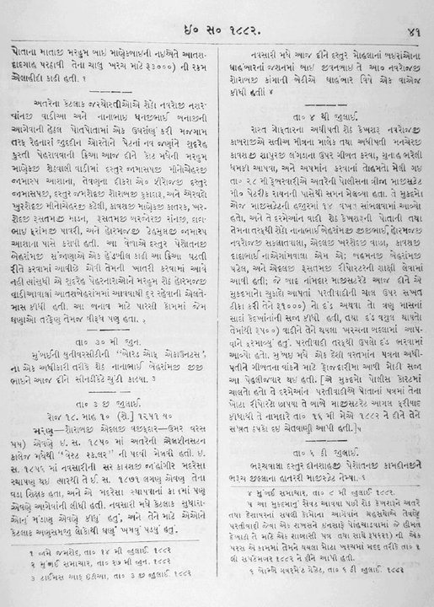
Saint Dasturji Jamshedji Sorab Kukadaru (1831–1900) needs no introduction to the Parsi community. His portrait adorns all the Agiaries, Atash Behrams & practically all the Parsi homes. He was the panthaky of the Kapawalla Agiary. He led a simple life of ashoi (righteousness), quite unlike most of the present day Panthakies, who lead a lavish life style. This highly learned & pious Dasturji had not only supported but had also personally performed the famous “Mazgaon Navjotes of 1882” of people born of inter-married parentage. In 1882, a group of poor dock workers living and working in Mazgaon Docks appealed to various Priests & High Priests and also petitioned the Bombay Parsi Panchayet ( BPP ) for being admitted to the Parsi fold, as being born of inter-married parentage. Not waiting for the Panchayet to decide, about 200 prominent Parsis collected funds and eminent Dasturjis performed the Navjote ceremony, in the presence of a large gathering on 26th June 1882. On 26th June 1882, eleven navjotes were performed (4 males & 5 females, age ranging from 35 years to 77 years & two children) on persons born of inter-married parentage by eminent priests including Saint Dasturji Kukadaru Saheb.

The following priests performed the “Mazgaon Navjotes”
Dastur Jamaspji Minocherji Jamaspasana.
Dastur Jamshedji Sohrabji Kukadaru (of Kappawala Agiary).
Dastur Hormusji Tehmulji Jamaspasana.
Dastur Phiroj Jamaspji Jamaspasana.
Ervad Dadabhai Framji Pavri (Panthaky of Mevawala Agiary).
Ervad Khershedji Mancherji Kateli.
Dastur Kavasji Manekji Katrak.
Ervad Khershedji Rustomji Madon.
Ervad Rustomji Burjorji Ranji.

Scanned details regards to the “Mazgaon Navjote of 1882” in Gujarati.

End Notes:
It is quite obvious, that the Parsi Com. is slipping away into oblivion, due to our own shorted-sighted contemporary
Akbars of the Faith, Pseudo Prophets of gloom & doom, and their Fuzzy Fundamentalist friends.

Points-to-ponder – by the Parsis:

1. Our empowered & enlightened women of the 20th/21st century, do not consider themselves as childbearing machines nor as stay-at-home mothers, only cooking and feeding the man of the house and his/their kids.
After graduating from University, they prefer to be independent for a while, hold a responsible job and travel. Who can blame them for that? Male dominated earlier days are long since past. If the community is going to be controlled and ‘straight-jacketed’ by the above identified conservative crowed; then we, today’s forward thinking moderate laity have ourselves to blame for this; our – liberal malaise. To fight the conservative crowd in any community, one has to develop the ‘Go for the Jugular’ attitude! . . . . The ‘Chalta hai’ approach never works with this mob, and invariably, they have the upper hand, by their bellicose.
Accept the inevitable demise of the community. But don’t try to suppress the Prophet’s teaching to children of inter-faith unions or adopted kids (from other communities) by Parsi couples, if we want the Parsi community to survive.

2. Our young mobeds during their training in madrasa’s – we should stop calling them ‘madrasas’, instead call them ‘seminaries’ – shouldn’t be confined to just learning the ritual prayers by rote; their general education on all topics should be of significance. It should be of overriding importance that they are conversant with the ‘Time lines of History’. I say this because, a senior, well respected practising Dastur, at a meeting few years ago, proclaimed that Zarathushtra was killed, while he was praying in the temple by a Turanian Mussalman. I shudder to think what my Jewish friend would say, if he had heard that remark.

3. Hindustan Times report by Reetika Subramanian. – “. . . . . . . . 12yr old Dinshaw Magol, who in a span of 3 years, had completed the three degrees of Zoroastrian priesthood study, including ‘Navar’, ‘Maratab’ and ‘Shamel’ at the Dadar Athornan Institute. This makes him the youngest priest in the country to become eligible to perform rituals at the 270-year-old fire temple in Udvada.”
What a waste of a beautiful mind! . . . If the young Magol, is going to be confined for the rest of its life performing ritual ceremonies but knows nothing about the world around him and its history. Don’t get me wrong! Ritual Prayers are important & essential, but my advice would be to allow him for the next 15years to grow in various other fields of art, science & humanities to become a well rounded Zoroastrian renaissance scholar of the 21st century.
To Quote Marcus Tullius Cicero’s (106 – 43BC) speech to the Roman Senate: ‘If we do not know what happened before we were born; then we are destined to remain as children.’

4. To the many proponents of ‘Protect, Preserve & Perpetuate our Parsi Panu’ in the community, I suggest they review the below web link/articles* that highlights the deplorable conditions that many in our community live under & step-up to help ‘WZO Trust Fund’ Mumbai; financially – to support the excellent work of uplift/help WZOTF does in the Parsi Mofussil. It’s not enough, to wrap oneself in the flag of pious-religiosity, thump the chest saying ‘Chiaya hame Zarthoshti’ & claim to protect ‘Parsi Panu’. Instead, ‘Put your Money where your Mouth is’ (i.e., Put Up! or Shut Up!)

5. Finally, a word to the wise scholars and media of the community; regarding the ubiquitous, exaggerated pseudo fables, as how ‘Parsi Pomp & Prosperity’ is based mostly on the ill-gotten gains of opium trade in the 19th century, by our Sethia’s. I say this again, because a recent novel ‘River of Smoke’ by Amitav Gosh, which is a work of fiction, based on fables of Parsi involvement in this ‘China Opium Trade’ by the British, is already getting rave reviews.
The July 2011 article in Parsiana –‘Tea and Opium’ had brought this subject of 'Opium Trade' by the Parsis of India, front and centre. My due-diligence on this topic by searching through the web sites of the aggrieved party – the Chinese – it became obvious to me that we the Parsis’, who are understandably squeamish about this matter, need not fret too much. The British, the French, the Americans & the Sassoon’s of Bombay are the ones the Chinese consider as the perpetrators of this shameful saga.
My paper – ‘The Dragon Awakens’** – a compendium of articles with Chinese web links and all references, makes no mention of Cama & Sons or Jivanji brothers or Jamshedji Jeejeebhoy etal. A few Parsis, no doubt were involved as minor players in this game of ‘Exchange Tea for Opium’ by supplying marine and other transport for this trade conducted by the British East India Company. But according to the Chinese, the major participants with the British in this trade/tragedy were the Sassoon’s of Bombay and not the Parsis!
My request to our young dons is to do due-research before writing scholarly articles/reviews on this subject, and to suppress the urge to rub the collective Parsi proboscis in the Mumbai mud, with these fables of ill-gotten fame & fortune by our Sethias of yore. Because, all this does is to give us, the senior Parsa’s, a proverbial ‘Heartburn’ and gives the ‘Y’ Gen Parsas wrong ideas as how to achieve fame and fortune in the 21st century.
Hope a detail review of this paper** clears our Parsa’s collective conscience and corrects the historical perspective of this colonial trade of shame & wanton destruction of China’s – ‘Yuan Ming Yuan’ cultural museum, – representing 5,000 years of an ancient civilisation.

6. . . . ‘QUO VADIS’ – PARSA? (E. Kanga)
* Live link→ Invisible Parsis: The poor of a prosperous community ←
*2011 Report of BSF funds distribution & work done by WZOTF Mumbai. – Available by request. (File Size – 5MB)
** Article – ‘The Dragon Awakens’ (with links to various reference sites) – Available by request. (File Size – 3.3MB)

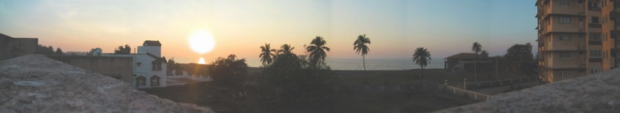
Sunset of the Parsa – ‘Holy See’?

* * * * * * *

Referenced List: – Of active live links & → articles available by request, in this paper.

* Article – ‘The Dragon Awakens’ -Giving true facts about the real players in this trade. – Available by request. (File Size 3.3MB)
** Article – ‘Auto de Fe’ Part II – Available by request. (File Size 1.3MB) & → ‘Gujarat State’ 2011/12 Data – Available by request
* Article – ‘Conversion in Zoroastrianism’ All you wanted to know, but were afraid to ask! – Available by request. (File Size -13MB)
** “ “ – ‘Religion of Zarathushtra is for all Mankind’ by Cyrus Mehta. – Available by request. (File Size -50KB)
→ “ “ – ‘CM - Narendra Modi addresses Parsis at Udvada’ – Available by request. (File Size -170KB)
→ ‘Sabarmati River Front Project’ – Video Link. – http://www.youtube.com/watch?v=4rNQOq1wSfs
* ‘Y-Chromosome – Indo-European language & Blood Types’ – Available by request. (File Size - 5MB)
** ‘Zoroastrians Search for their Roots’ by Zubair Ahmed – Available by request. (File Size -80KB)
*** ‘FYI – A Celebration of Human Genetic Diversity over Millennium’ – Available by request. (File Size -115KB)
→ Article – ‘Religious Impulse & Evolution.’ by Gopi Krishna – Available by request. (File Size – 30 KB)
* http://thelede.blogs.nytimes.com/2012/10/09/my-small-video-star-fights-for-her-life/?smid=fb-share
** ‘Talibanisation of Zoroastrianism’ by P. Kakodkar. – Available by request. (File Size - 40KB)
→ Article – ‘Living in the Light’ – Available by request. (File Size – 240 KB)
* ‘ANGLICISATION OF THE PARSIS’ by Dr. Polly Noshir Chenoy – Full article by request. (File Size – 180KB)
→ Article – ‘+The Tata Group History 1868- 2012’ – Available by request. (File Size – 1.34 MB)
→ Article – ‘The Wadias of India: Then & Now’ by Khorshed Jungalwala. – Available by request. (File Size – 170KB)
→ http://www.cnngo.com/mumbai/life/what-would-mumbai-be-without-its-parsis-032539
→ Invisible Parsis: The poor of a prosperous community
→ http://en.wikipedia.org/wiki/Dadabhai_Naoroji → http://en.wikipedia.org/wiki/Sir_Jamsetjee_Jejeebhoy,_1st_Baronet
→ http://en.wikipedia.org/wiki/Jamsetji_Tata → Invisible Parsis: The poor of a prosperous community
→ Ratan Tata’s second act. (pdf file) – Download (4.7MB)
→ Article – ‘The Wadias of India: Then & Now’ by Khorshed Jungalwala. – Available by request. (File Size – 170KB)
* Article – ‘Sir Dhunjibhoy Bomanji’ Full write-up with UK photographs. – Available by request. (File Size - 380KB)
→ Article – ‘List of Notable Parsis’ (with links to their life) – Available by request. (File Size - 1.0MB)
→-http://defenceforumindia.com/forum/politics-society/42172-field-marshal-sam-manekshaw-s-lecture-leadership- discipline.html
→ Article – ‘Prominent Zarathushties of India’ (with links to their life) – Available by request. (File Size - 400KB)
→ “ “ – ‘PARSIS’ The World’s Smallest Nation’ – Available by request. (File Size – 1.7MB)
→ Article – ‘Sir Dinshaw Petit – First Baronet’ – Available by request. (File Size – 76KB)

→ Article – ‘Homi J. Bhabha’ – Complete article available by request. (File Size – 76KB)

→ More – ‘Notable - Noteworthy of the Clan’ – look up 2 Vol. Set – ‘Parsi Lustre on Indian Soil’ by H. Darukhanawala.
→ And – ‘Enduring Legacy: Parsis of the 20th Century’ – Edited and published by Nawaz B. Mody - 4 Vol. Set.
→ Also – ‘Prominent Zarathushties of India’ (with links to their life) – Available by request. (File Size - 400KB)

→ Demographics - Case of Parsis in India‏ <http://www.jsk.gov.in/articles/demographic_transition_sayeed_unisa.pdf>
*2011 Report of BSF funds distribution & work done by WZOTF Mumbai. – Available by request. (File Size – 5MB)
** Article – ‘The Dragon Awakens’ (with links to various reference sites) – Available by request. (File Size – 3.3MB)
→ http://www.zoroastrian.org.uk/vohuman/SiteMap/ProminentZarathushtis.htm *e
E. Kanga. Nov. 2012.
<ekanga@sympatico.ca>

